Patterns of Solar Field Development in the Blackstone Watershed: Hot Spot Analyses and distance to Wetlands, Critical Habitat, and Climate Resiliance Priority Lands

By Adlai Nelson ‘24 & Finnegan Wertz ‘23
anelson@clarku.edu fwertz@clarku.edu

- Abstract

Since 2003, many solar farms have been built in the Blackstone River Watershed as an alternative to non-renewable methods of power generation. Despite the large scale climate benefits of transitioning to renewable energy, solar farming requires the clearing of large swaths of land and the introduction of impermeable surfaces to the environment, which affects precipitation runoff patterns and may impact the functioning of the local watershed. Large solar farm clearings may also infringe on important or fragile ecosystems, such as wetlands, critical habitats, and climate resilience. This study identifies hotspots of solar development in the Blackstone watershed and proximity to these areas of ecological concern. We found that nearly half of solar fields directly infringe on at least one type of ecologically important habitat, and most others are within close proximity. The results of this study intend to inform the Blackstone Watershed Collaborative (BWC) of the locations and potential impacts of solar farms within the drainage boundary.

- Introduction and Problem Statement

The purpose of this investigation is to reveal what types of lands are most commonly cleared for solar farm construction and solar farm proximity to areas of ecological importance in the Blackstone River Watershed. The Blackstone River Watershed covers approximately 215,000 acres of south-central Massachusetts and northern Rhode Island and channels water from as far north as Worcester into the Narragansett Bay in Pawtucket, Rhode Island. Approximately 95,000 acres are classified as areas of ecological importance within the watershed boundaries. Areas of ecological importance are defined as climate resilience priority lands, critical habitats, and wetlands important for native plant and animal habitat, maintaining biodiversity, and protecting endangered species. Climate resilience priority lands are identified and defined by the Nature Conservancy’s Center for Resilient Conservation Science as lands that are important for supporting biodiversity as climate change progresses. These classifications are identified based on swaths of land with varying habitats and ecological systems that can serve as wildlife corridors and support many different and non-isolated populations. Critical habitats include areas identified by MassGIS’s BioMap2 project to be areas either of core habitat for rare species or critical natural landscapes of large areas with minimally developed land. Wetlands, which are identified as fragile ecosystems by Massachusetts Department of Environmental Protection (MassDEP) under The Wetlands Protection Act are also included as an area of ecological importance. We hope to use these resources to understand the impact of solar fields on key ecological areas in the Blackstone River Watershed.

- Data

The Massachusetts solar dataset contained the total cleared area around solar fields, including the year the solar field was created. These data were created following the remote sensing methods outlined in Tao et al. (2023). The dataset for Rhode Island solar was also created by Clark Geography. Both the MA and RI solar datasets were provided by Prof. John Rogan. Shapefiles of ecologically important areas- critical habitat and climate resilient lands- were created by Claudia Buszta in a previous project. Critical habitats were created by merging Bureau of Geographic Information (MassGIS) Biomap polygons using the layers rare species core habitat, aquatic core habitat, and landscape blocks with Rhode Island Geographic Information System (RIGIS) Natural Heritage protected species habitat areas. Climate resilient lands were taken from The Nature Conservancy’s climate resilient lands and habitats.
Land cover data was collected for all years from the Multi-Resolution Land Characteristics (MRLC) consortium’s 2019 release of the National Land Cover Database (NLCD). These data were raster images, with a resolution of 30m x 30m.
The shapefile of the study area, the Blackstone River Watershed, was downloaded from MassGIS

- Methodology

Processing Data
All data was projected into NAD 1983 Massachusetts StatePlane FIPS 2001. All analysis was done in ArcGis Pro.
The solar field polygons for Massachusetts and Rhode Island were clipped to the watershed boundary and merged to create a complete map of solar fields in our study region (Chart 1).
Landcover data were downloaded from Google Earth Engine (GEE), and subsequently loaded into ArcGIS. Each image was then transformed using raster to polygon, then clipped to the Blackstone Watershed boundary. Calculate field was then used to create the field ‘landcover’, transforming the numerical index to a character type field using a python elif expression. The 20 total land cover types from the NLCD were condensed into the following: perennialsnow, openwater, developed, barren, forest, shrubland, herbaceous, cultivated, and wetlands (Chart 2).
Current wetlands were calculated using select by features on the NLCD 2019 layer, using the argument landcover = wetlands, and then data ->export features.

Area Analysis
NLCD data was only available for 2001, 2004, 2005, 2008, 2011, 2013, 2016, and 2019, and as a result, we had to exclude a total of four solar fields, three of which were built before 2001, and one that had the year built labeled as 0. Solar clearings were selected using select by attributes, using the year field. Clearings were divided into years 2001-2004, 2005-2006, 2009-2011, 2012-2013, 2014-2016, 2017-2019, and 2020-2022 (Chart 3). Tabulate area was used to calculate the amount of area from each land cover type overlapped with each solar field. These tables were then joined by attribute with the attribute tables of the solar fields for each time period. All solar field shapefiles were subsequently merged into a complete file containing the cleared area of solar fields built in the Blackstone Watershed since 2001 (Chart 4).

Distance from key areas
Distance from wetlands, critical habitats, and climate resilient areas was calculated using the near tool (Chart 5).

Hot Spot Analysis
Solar fields are a unique type of impervious surface, and their ability to impact hydrological processes is dependent on many factors: panel orientation, soil type, and management strategies just to name a few (Yavari et al., 2022). We found no conclusive study that measured the impact of the size of the solar fields in relation to hydrological disruption, however, for our hot spot analysis, we chose to weight it by field area, reasoning that greater disruptions in natural environments still answer our research question about ecological impacts. For out hot spot analysis, we chose to perform both a Getis-Ord Gi* hot spot analysis and an emerging hot spot analysis using a space time cube. This methodology follows authors Kahn et al.’s (2023) use of both statistics on their data, however, unlike Kahn et al., we chose to group our features into a fishnet grid before performing the Getis-Ord Gi* hot spot analysis. To perform this analysis, firstly, we used calculate field to create an additional cleared_area column for each solar field, recording the shape area in a standalone field. Feature to point was then used to extract the centroid of each solar field. From the centroids, the incremental spatial autocorrelation tool was run, using cleared_area as the input field. Using a distance increment of 100m, the peak z score was determined to be at 2700m distance. A blank fishnet was created, using create fishnet, the BRW shapefile as the boundary, and 2700m as the cell size. The solar field centroids were then spatially joined to the empty fishnet, summing the cleared_area column. From the resulting object, a Getis-Ord Gi* hot spot analysis was run, using the cleared_area field as the input field, and default values for everything else. For the emerging hot spot analysis, convert time field was run to convert the year into a field of type date. Create space time cube by aggregating points was then ran, using 2700m as the cell size and default values for everything else. From this space time cube, emerging hot spot analysis was completed (Chart 6).

- Results

The average size of solar fields in the Blackstone River Valley is 87,350 sq meters, or 21.5 acres. Half of all solar fields are smaller than 13 acres. The largest is located in Northbridge, MA and totals 190 acres.
Of land cover cleared for solar fields, over half (58%) was forested (See Table 1). The second most common land type was grassland (16%), then cultivated (12%). Developed, barren, and shrubland land types were less likely to be developed for solar farms, and wetlands and open water comprised less than 1% of land cover converted. Regarding water boundaries, 11 out of 65 solar field polygons directly bordered a tributary or body of water and 47 out of 65 were within 100 meters.
The results of the emerging hotspot analysis show that most recent development of solar farms have occurred in northern Rhode Island (see Figure 1), whereas the results of the Getis-Ord Gi* hot spot analysis show solar farms clustered in southern Massachusetts (see Figure 2). One flaw with this analysis is that there could be methodological differences in how the MA and RI solar field data were collected. The earliest entry for the RI solar clearings in our study area is in 2016, while the MA data goes back further than that. This could represent that no solar fields were created in RI in the BRW before 2016, or the data could have only contained solar fields since 2016.
Of the 65 solar fields created since 2003, 30 directly infringe on at least one area of ecological concern. Of these, 12 infringe on designated climate resilience areas (Figure 3), 19 were built on critical habitat (Figure 4), and 4 were built on top of wetlands (Figure 5). Additionally, 6 additional solar fields are located within 100 meters of wetlands, 3 within 100 meters of climate resilience land, and 11 located within 100 meters of critical habitats (see Table 2). one of the three types of ecological concern and none are located more than a kilometer from either wetland, critical habitat, or climate resilient priority land.

- Conclusion

While the push towards renewable energy is necessary and beneficial for the broader environment, the construction of solar fields within the Blackstone River Watershed has been detrimental to the integrity of natural environments essential for maintaining biodiversity, wildlife and vegetation habitat, and climate resilience of endangered populations. The relatively large portion of solar farms created in these key ecological areas is cause for concern.

The effect of solar fields on hydrologic functioning is not yet certain (Yavari et al., 2022). Most solar fields consist of long rows of slanted panels. These surfaces are chemically treated and impermeable, causing precipitation that lands on the slanted solar panels to run off in a dripline. Concentrated run off from solar panels may cause changes in soil moisture patterns, promote erosion, and pollute streams if the soil beneath the solar panel drip lines is compacted from construction or oversaturated. Attempts to study the impact of solar panels on run off have only included simulated models, and results vary based on the model used, factors considered, and geography (Yavari et al., 2022). In Massachusetts law, certain recommendations are given to mitigate run off from solar panel constructions. These depend on the slopes of fields, panel placement and requiring post-construction stormwater management plans (Wetlands Protection Act, 2014). Further research could include soil type and management strategies of solar fields to better understand hydrological impacts.

- Tables, Charts, and Figures

Table 1: Landcover type replaced
Land cover type replaced | Area (meters squared) | Percentage of total area
Forest | 3,324,881 | 58.45
Grassland | 921,077 | 16.19
Cultivated | 687,075 | 12.08
Developed | 477,712 | 8.398
Barren | 170,551 | 2.998
Shrubland | 96,840 | 1.702
Cultivated | 7,529 | 0.1323
Wetlands | 2,660 | 0.0468

Table 2: Infringement on key ecological areas
 | Mean distance (meters) | n solar fields that overlap | n solar fields within 100m
Wetlands | 531 | 4 | 6
Climate Priority land | 859 | 12 | 3
Critical habitats | 598 | 19 | 11

Chart 1:
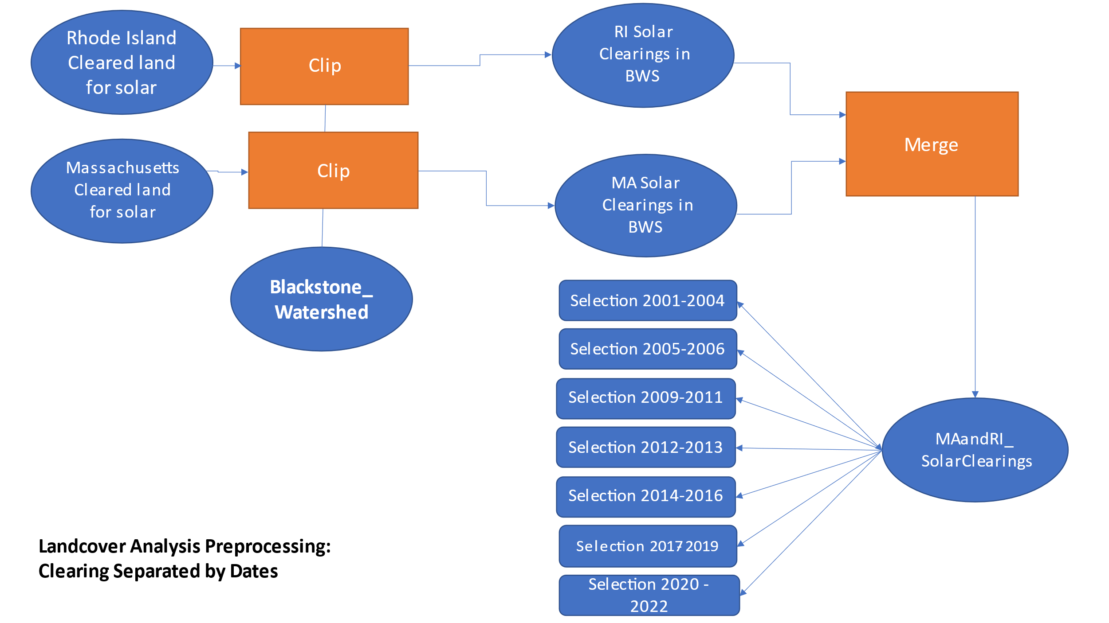
Chart 2:
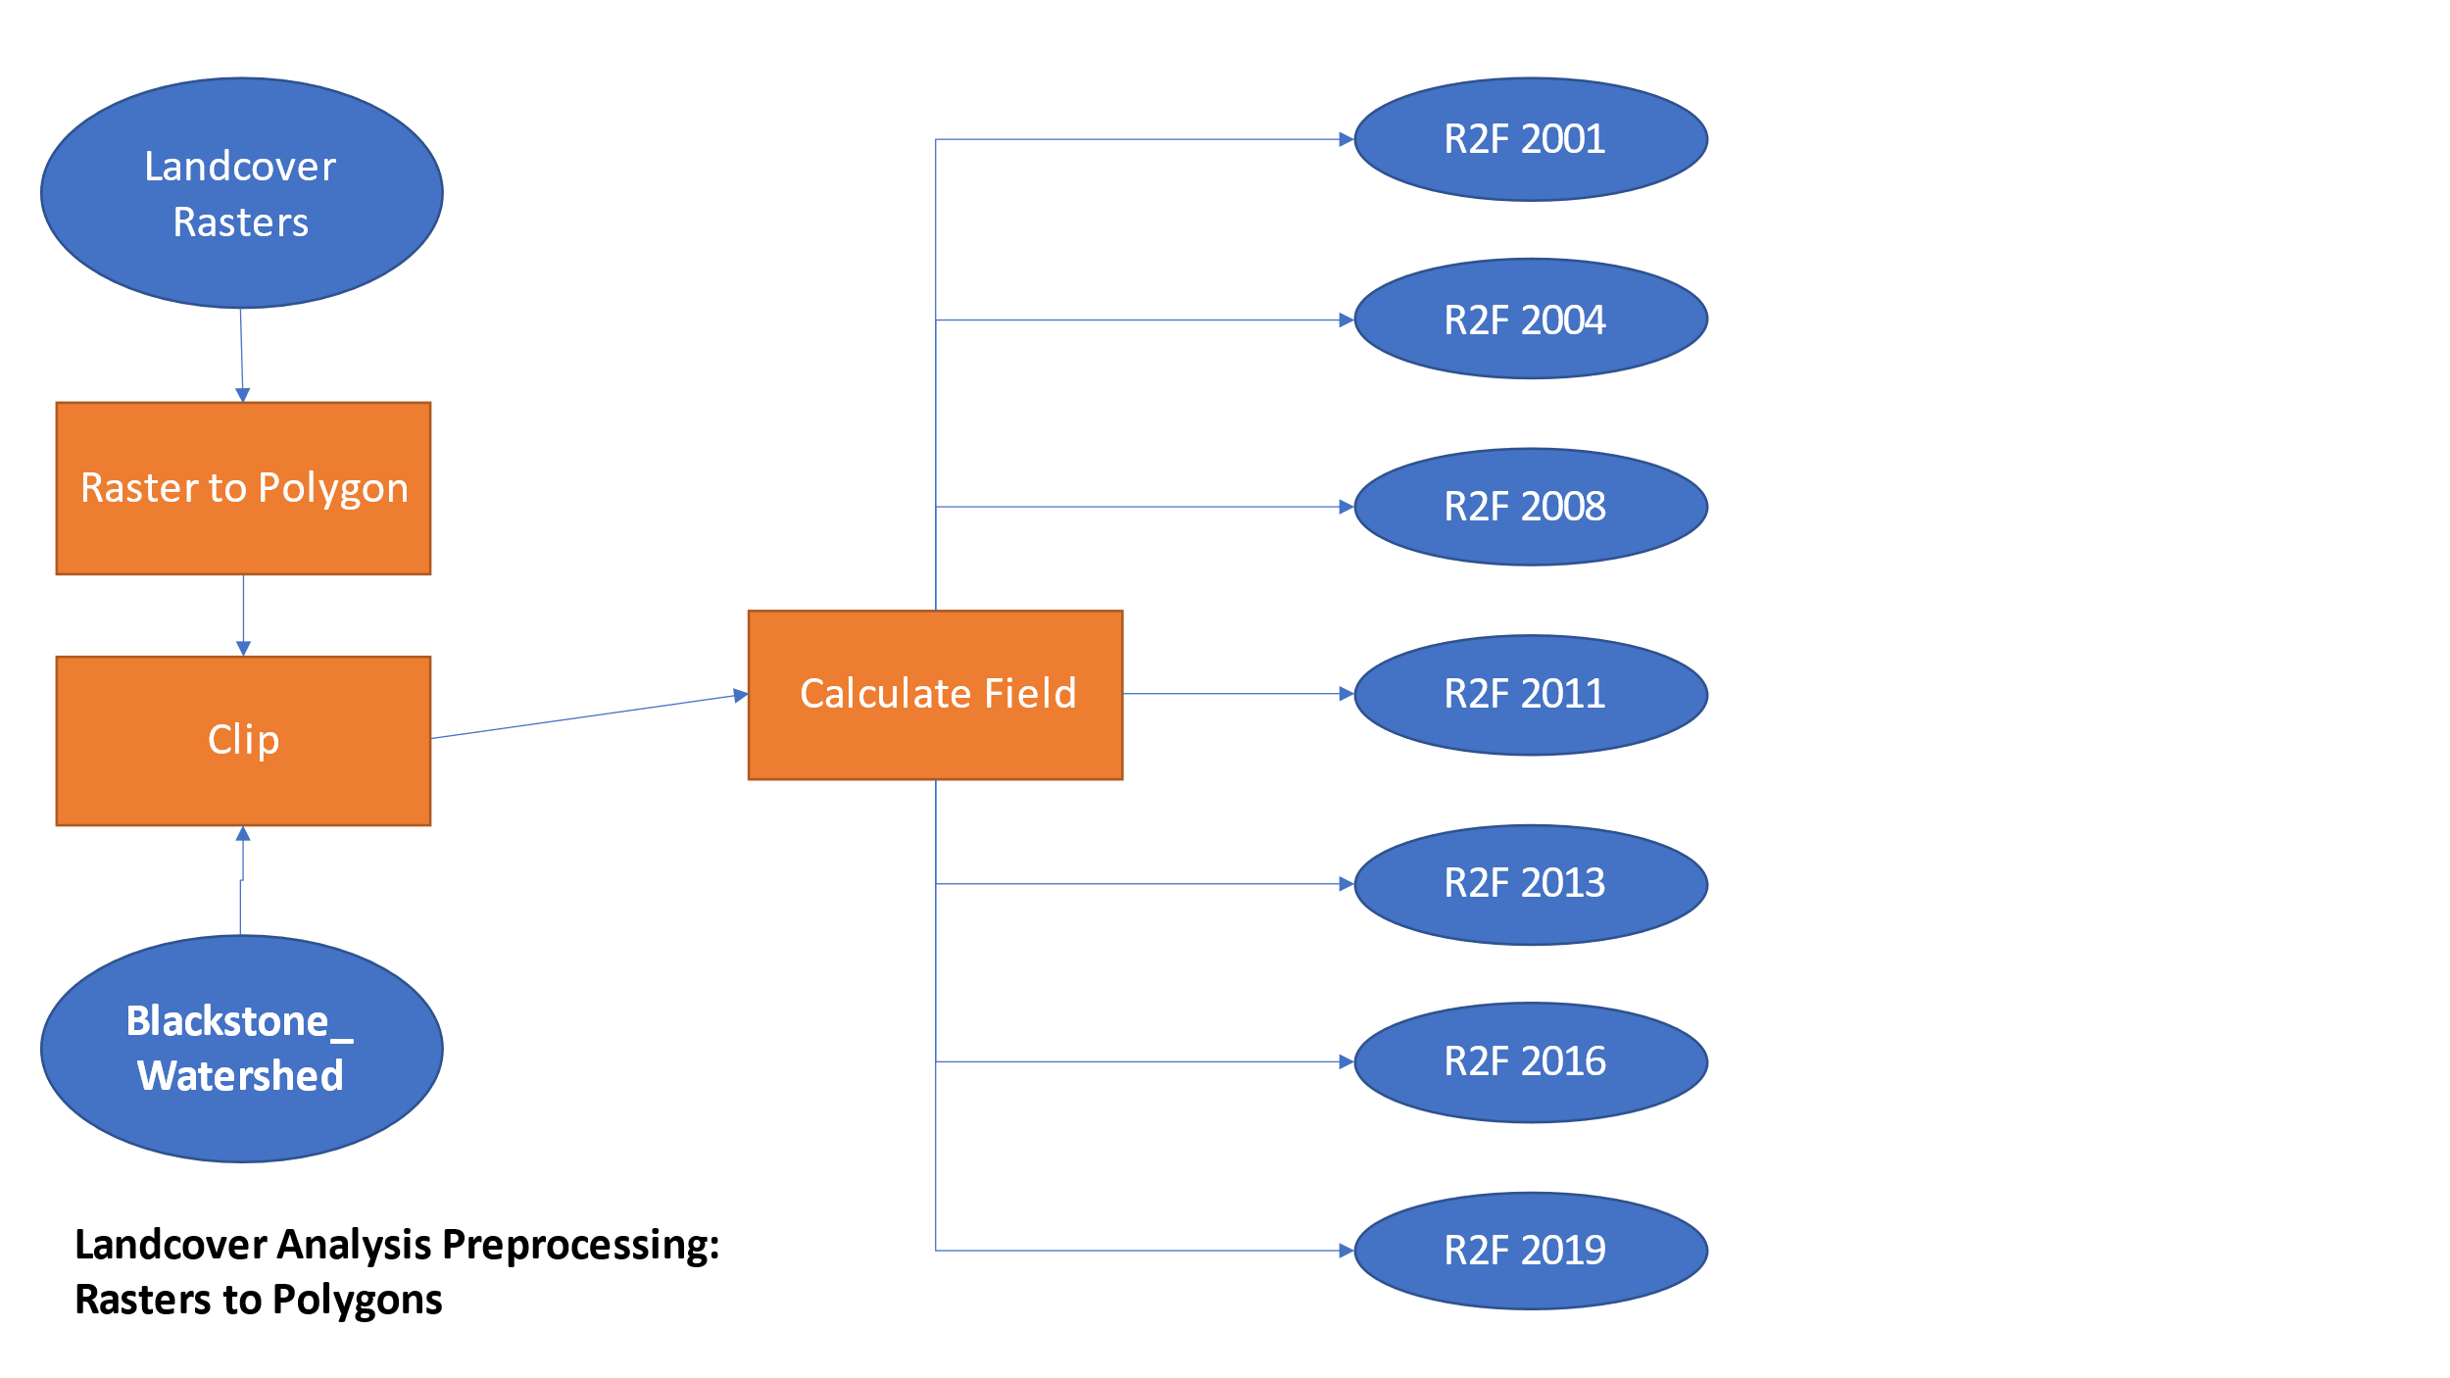

Chart 3:
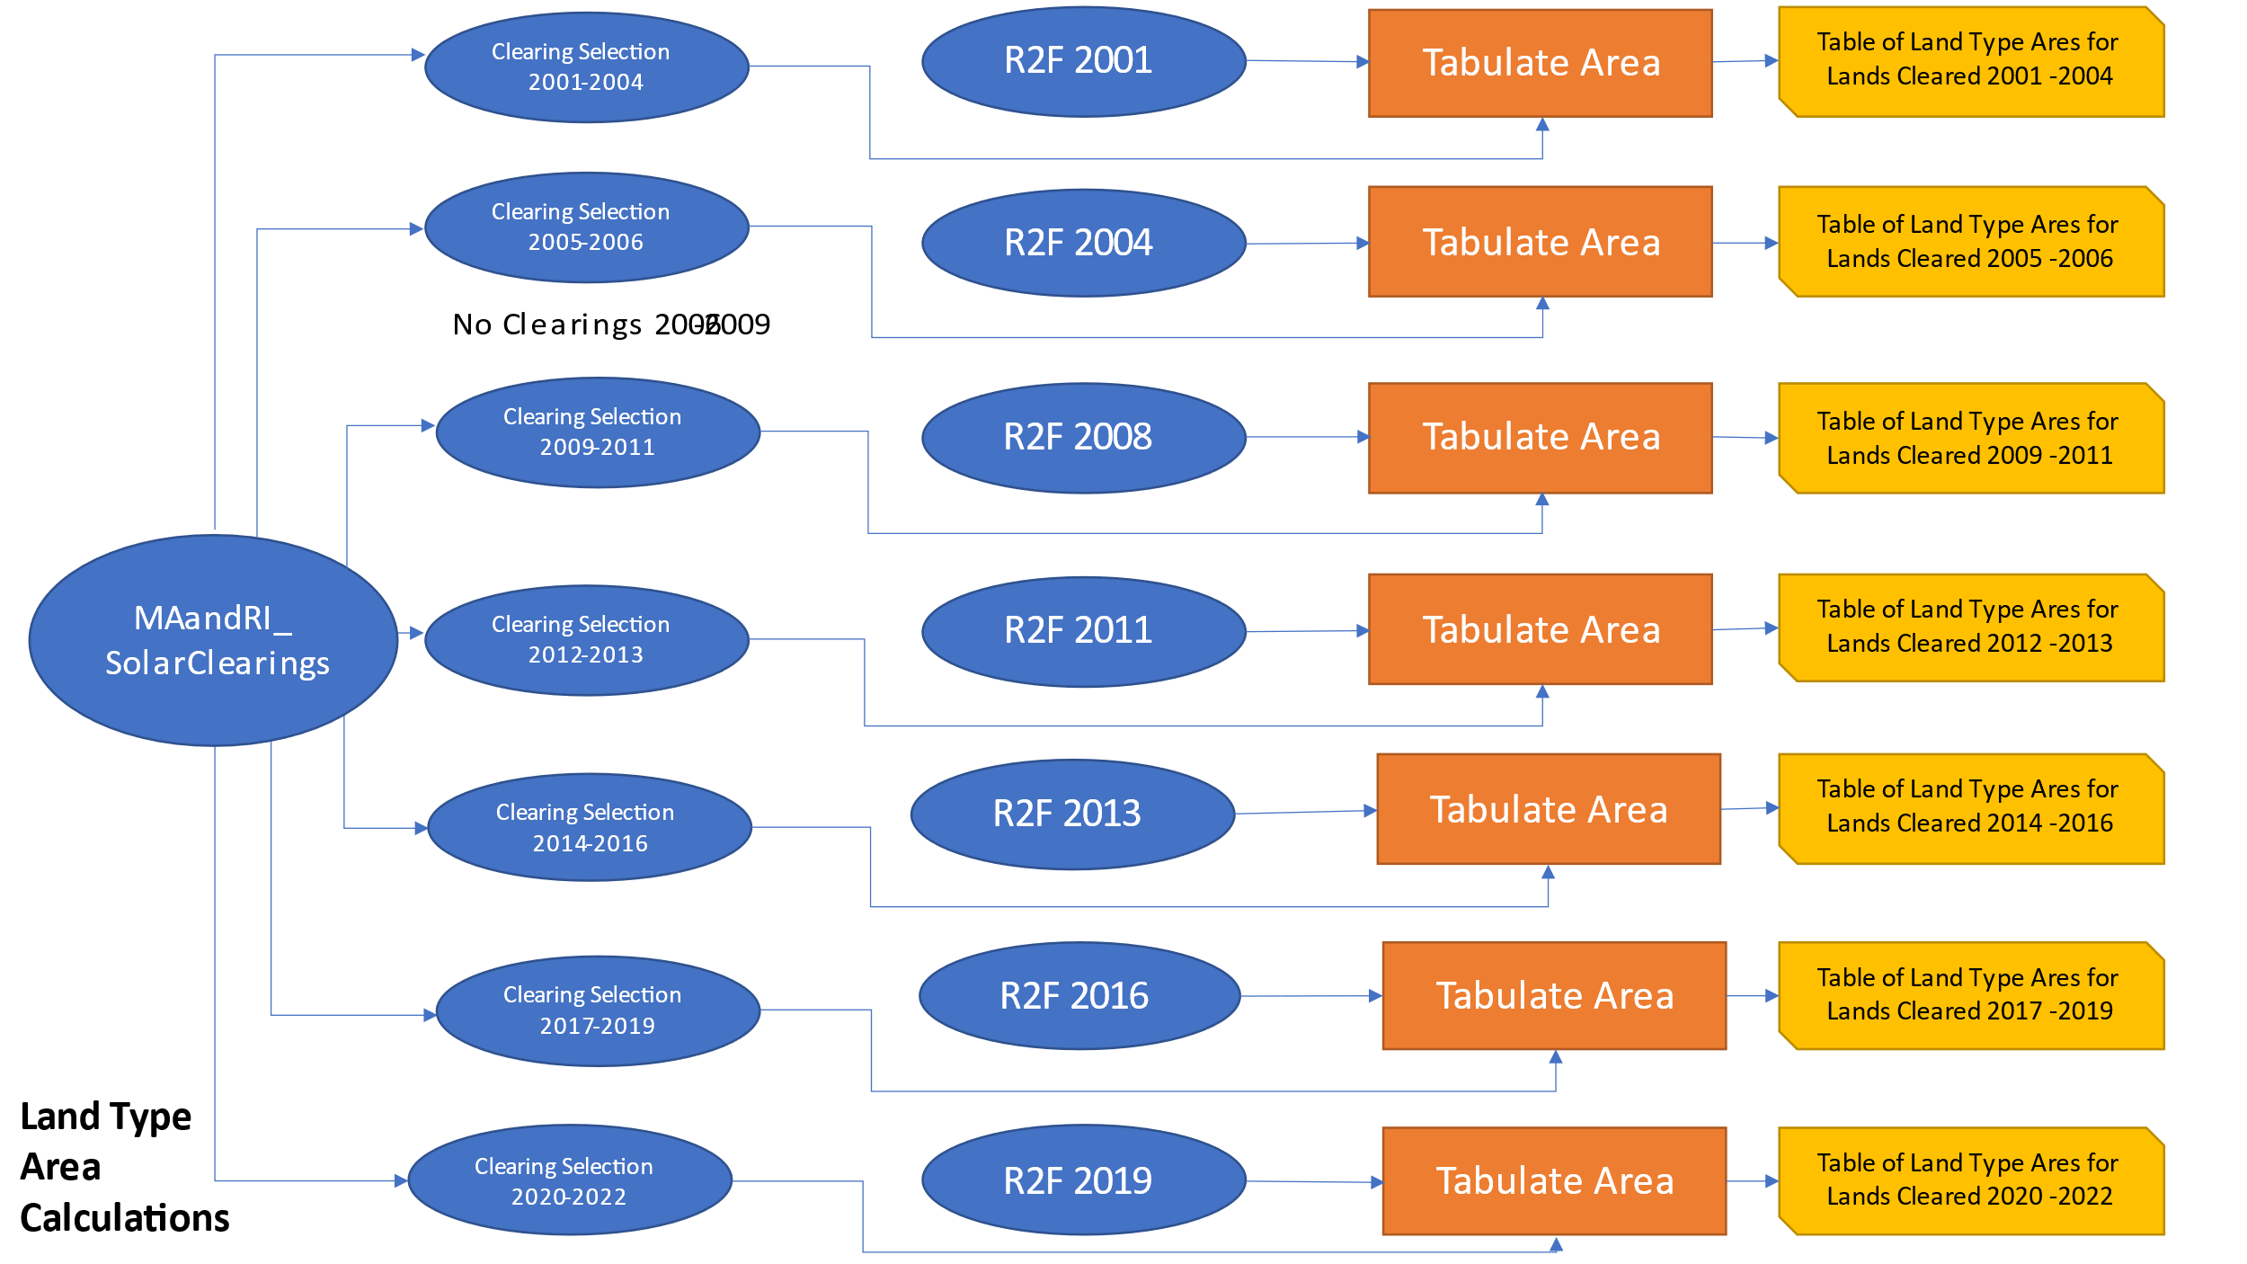
Chart 4:
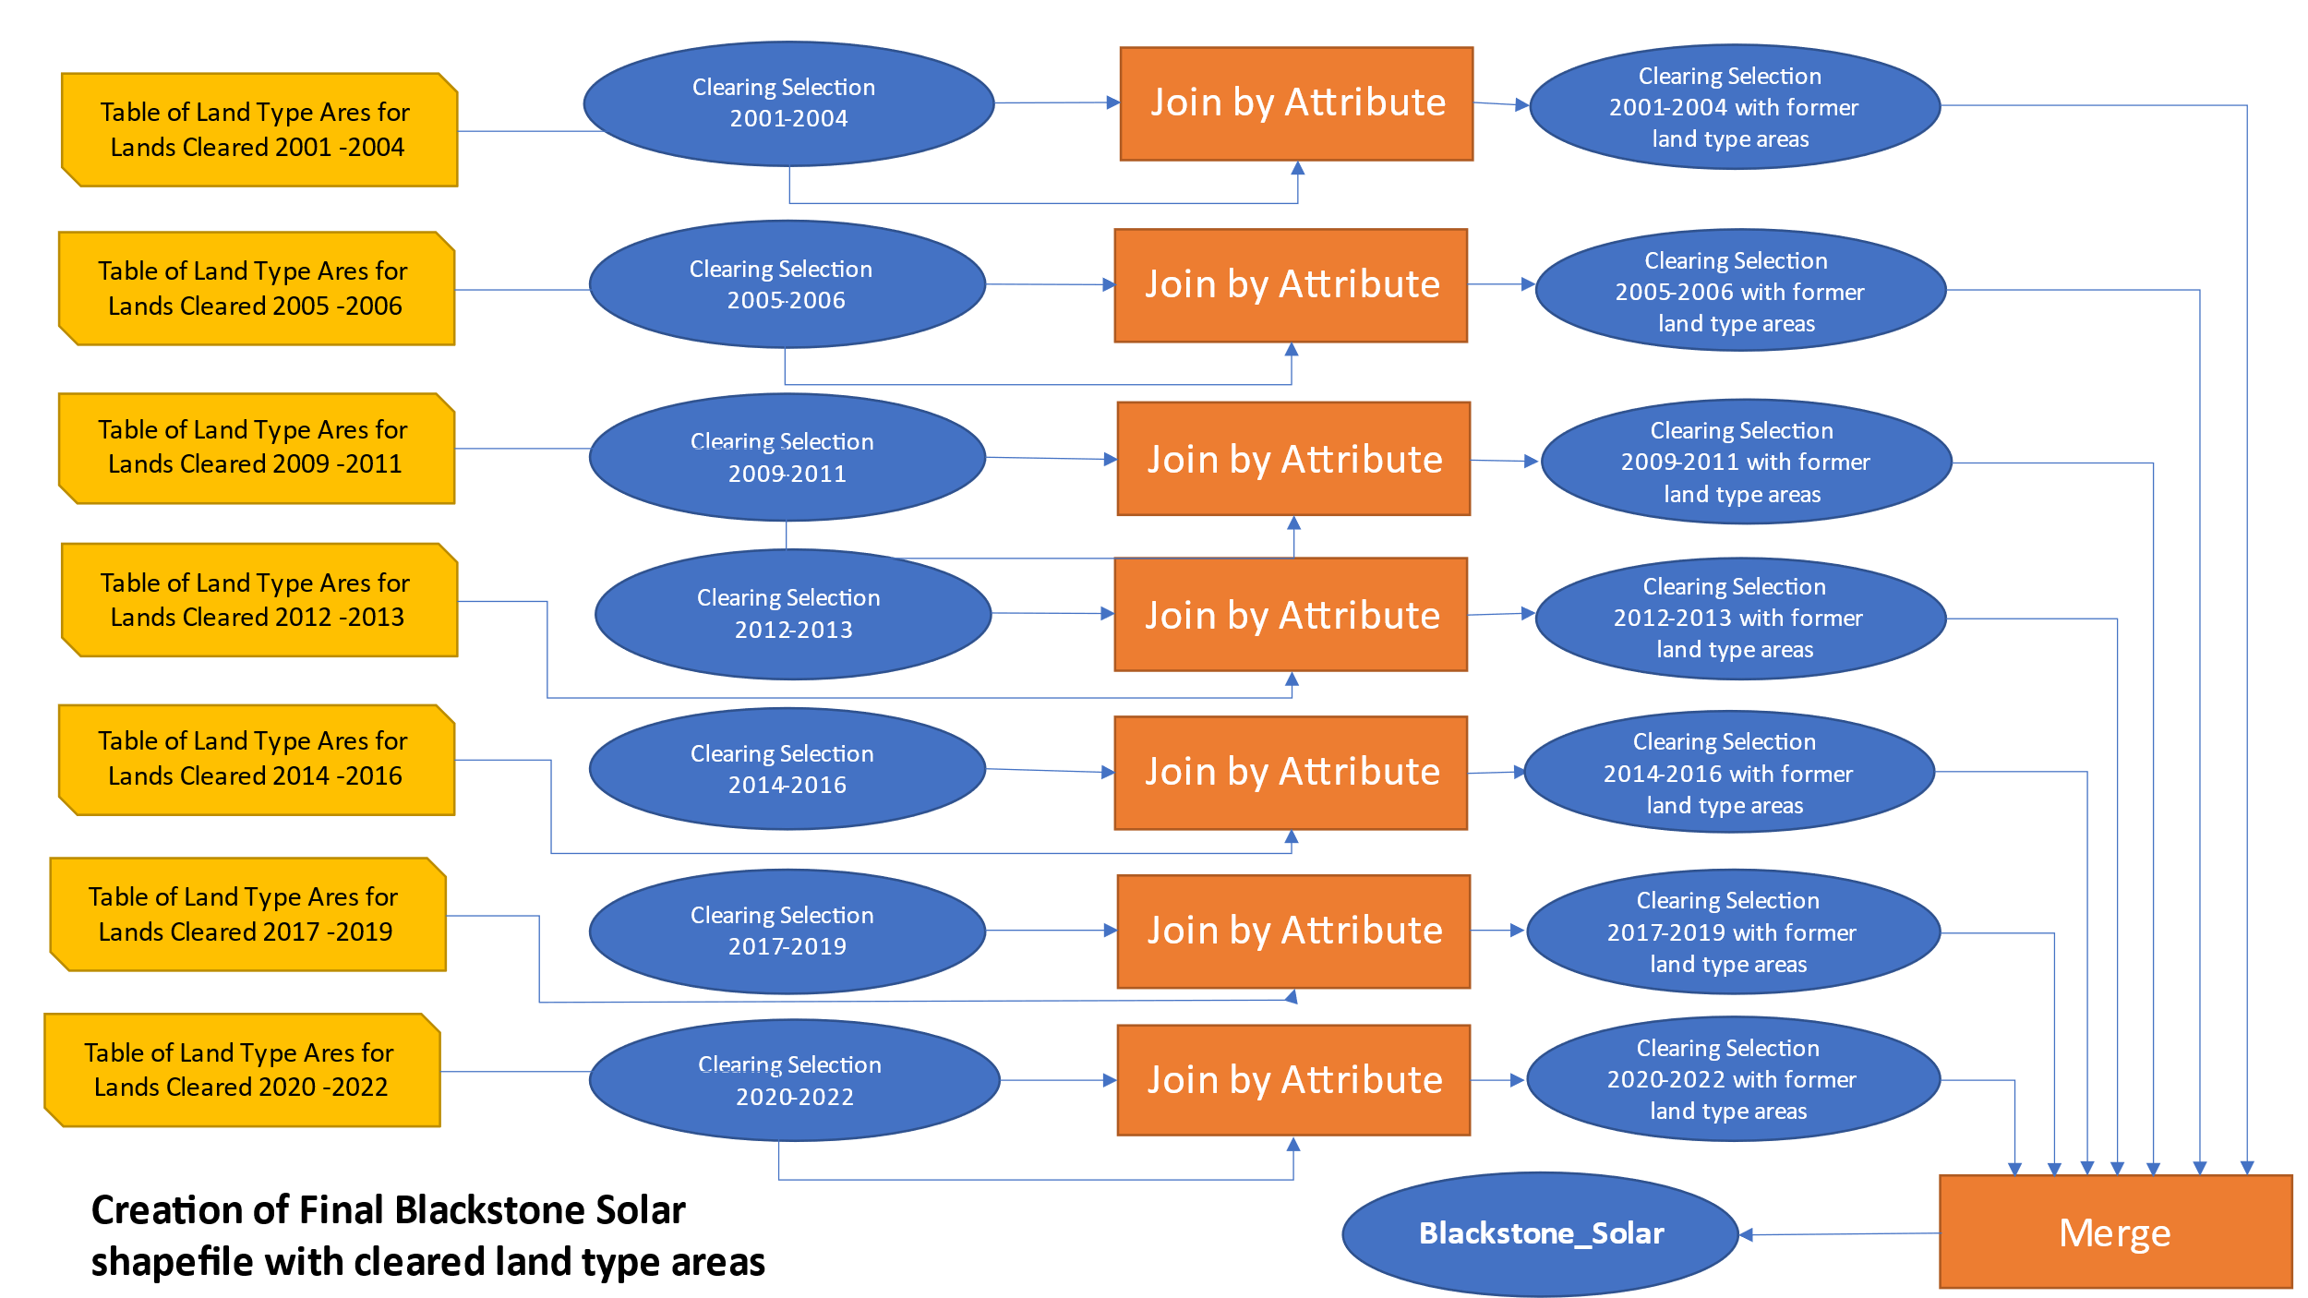

Chart 5:
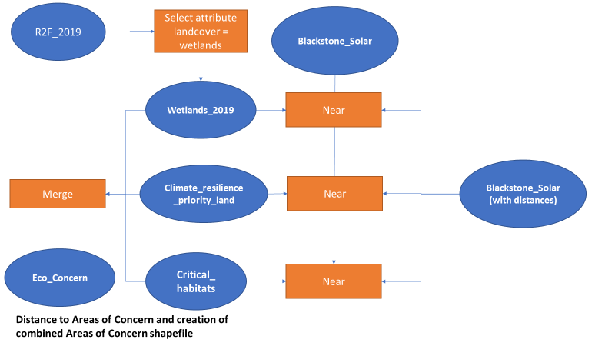
Chart 6:
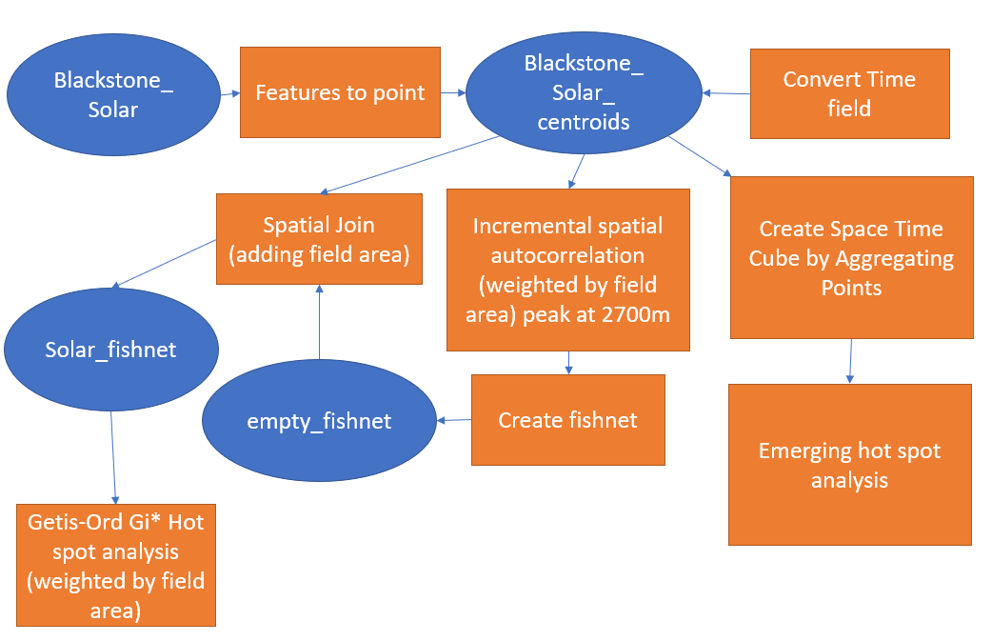

Figure 1: 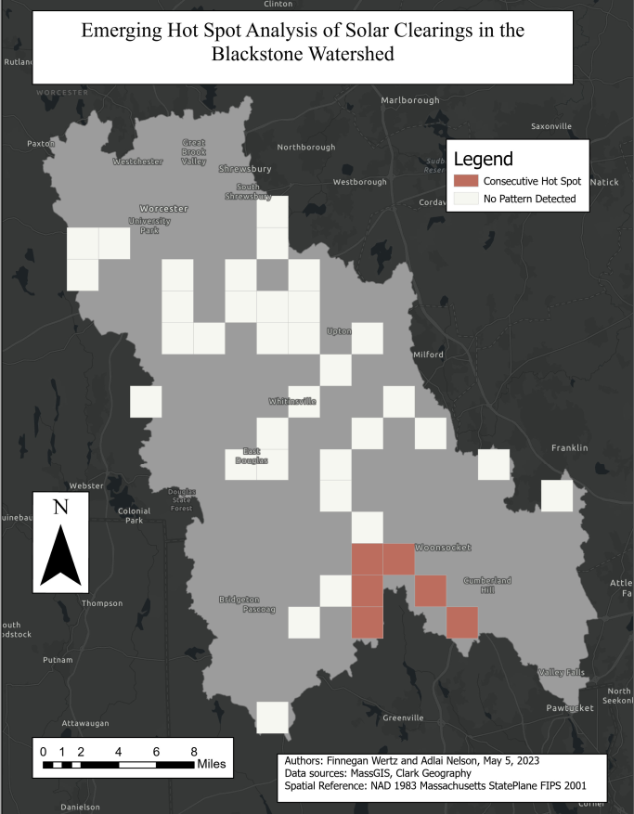
Figure 2: 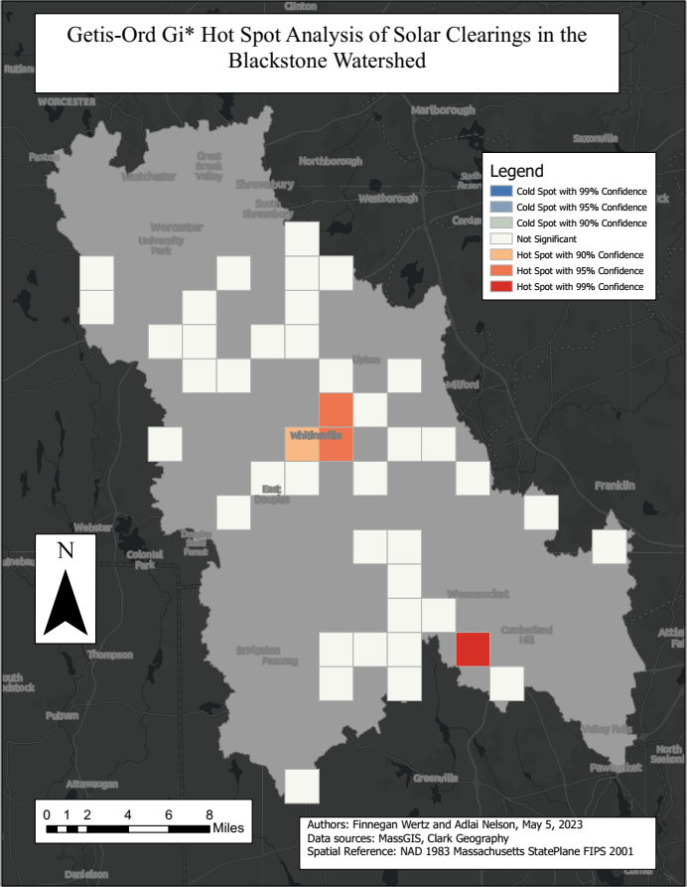Figure 3: 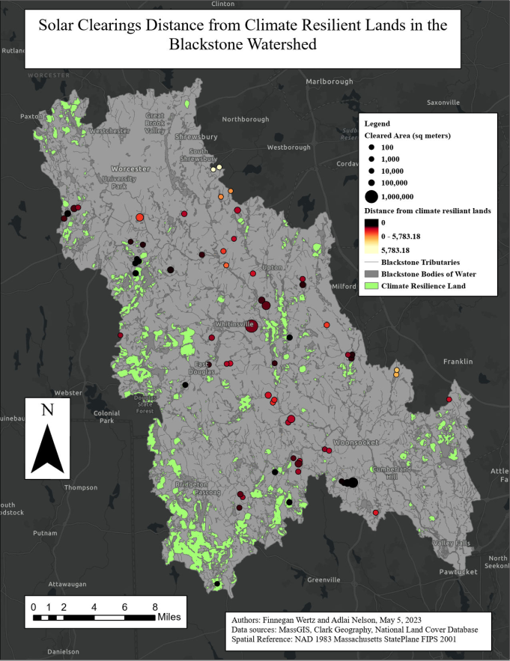
Figure 4: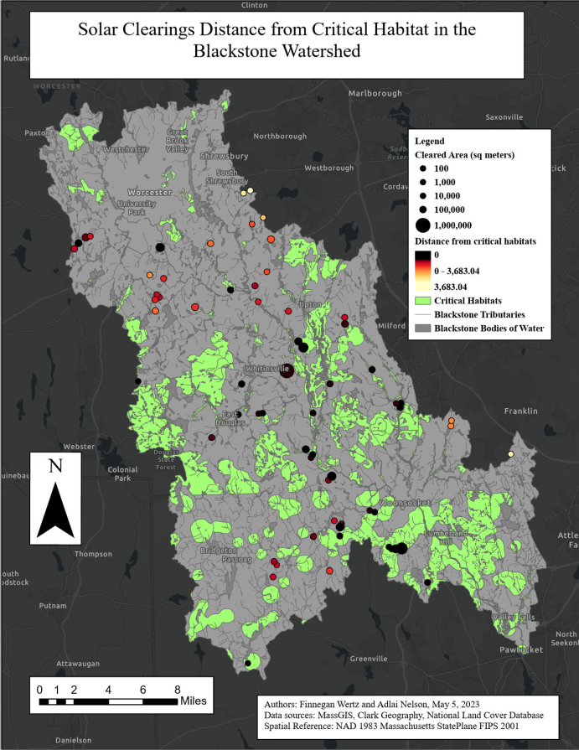Figure 5: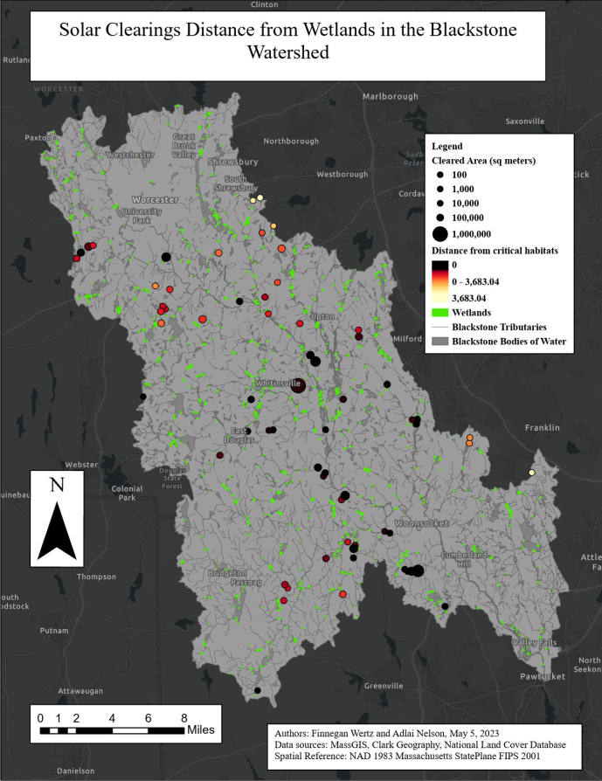

- References

Anderson, M.G., A. Barnett, M. Clark, C. Ferree, A. Olivero Sheldon, J. Prince. (2016). Resilient Sites for Terrestrial Conservation in Eastern North America. The Nature Conservancy, Eastern Conservation Science.
Biomap, (2022). Mass Wildlife and The Nature Conservancy. Retrieved from: https://biomap-mass-eoeea.hub.arcgis.com/
Khan, I. U., Vachal, K., Ebrahimi, S., & Wadhwa, S. S. (2023). Hotspot analysis of single-vehicle lane departure crashes in North Dakota. IATSS Research, 47(1), 25-34.
RIGIS, 2017. Rhode Island Geographic Information System (RIGIS) Data Distribution System. Environmental Data Center, University of Rhode Island, Kingston, Rhode Island (last date accessed
Tao, S., Rogan, J., Ye, S., & Geron, N. (2023). Mapping photovoltaic power stations and assessing their environmental impacts from multi-sensor datasets in Massachusetts, United States. Remote Sensing Applications: Society and Environment, 30, 100937.
The Wetlands Protection Act, M.G.L. c. 131 § 40 (2014)
Yavari, R., Zaliwciw, D., Cibin, R., & McPhillips, L. (2022). Minimizing environmental impacts of solar farms: a review of current science on landscape hydrology and guidance on stormwater management. Environmental Research: Infrastructure and Sustainability, 2(3), 032002.

- Team effort:
Paper
Abstract, Introduction, Results, and Conclusion sections of this paper were written by Finnegan Wertz, and the Data and Methods sections were written by Adlai Nelson. Figures and References were created and added jointly.

Analyses
Methods of analysis, project goals, and data decisions were made jointly and in-person. Collection and preprocessing of land cover rasters was done by Adlai Nelson, while preprocessing of shapefiles received from John Rogan was done by Finnegan Wertz. Analysis of land types cleared for solar farms were performed jointly, and distance calculations and hot spot analyses were performed by Adlai.

