Blackstone River Watershed: Prioritizing Culvert and Dam Examination Based on Habitats of Concern in Relation to River Connectivity

By Claudia Buszta
MSGIS candidate at Clark University
cbuszta@clarku.edu

16 December 2022

Abstract
This analysis is a result of collaboration between the Blackstone Watershed Collaborative and the author as a final project for the Advanced Vector Analysis course at Clark University. The Blackstone Watershed Collaborative (BWC) seeks to prioritize restoring connectivity within the Blackstone Watershed as part of an ongoing multi-state conservation effort. Dams and culverts were the targets for this analysis. Each were assigned a habitat suitability index value based on four input variables of importance in this endeavor. A hot-spot analysis revealed two significant areas where efforts could be prioritized, and a large cold spot of low-priority culverts and dams. This project is meant as guidance for the direction of future work by the BWC.
Objectives and Research Question
The purpose of this project is to determine where the Blackstone Watershed Collaborative should prioritize addressing connectivity related to dams and culverts in the Blackstone River Watershed. The watershed encompasses a large area of central Massachusetts, extending into Rhode Island and to Narragansett Bay (Map 1, Map 2). The analysis will be done by developing a habitat suitability index, where areas will be scored based on four variables:
- Proximity to polluted waterways
- Proximity to developed land cover
- Proximity to habitats identified by state organizations as areas of critical conservation concern
- Proximity to prioritized climate change resilient landscapes
The index will assign dams and culverts located within the Blackstone Watershed a value from 0 to 1, with higher scores indicating being nearer or entirely within suitable habitat for native species that should be prioritized for conservation efforts. For variable 1, culverts and dams closest to polluted waterways should be prioritized as connectivity would dramatically improve native species habitat that is already being threatened by the contaminated waters. Variable 2 is similar in concept, where dams and culverts closer to potential sources of pollution and interference (expanding development, roadway runoff, human disturbance, etc.) should be prioritized for potential connectivity improvements.
Variables 3 and 4 identify areas of critical habitat concern that are already prioritized for conservation. Therefore, dams and culverts in those locations or close to them should be prioritized to ensure they are not interfering with native wildlife or contributing to habitat degradation. Variable 3 considers locally identified habitats where native species have been confirmed to reside in or use as nesting grounds. Variable 4 is derived from the Nature Conservancy’s Center for Resilient Conservation Science. They have identified lands around the US that will continue to function and support biodiversity as climate change advances in the near future. An important element of this data is that lands were considered more resilient based on their connectiveness to other resilient lands, the idea being that these will act as corridors for wildlife to access varying habitat types, rather than being limited to small, isolated patches of habitat (Anderson et al., 2016). For this reason, dams and culverts within prioritized resilient landscapes should be considered to ensure limited interference in the connectivity of waterways.
Data
Data for this analysis was obtained by correspondence with Stefanie Covino, Project Manager at the Blackstone Watershed Collaborative, and sourced from multiple online databases. Culvert locations were provided by the North Atlantic Aquatic Connectivity Collaborative (NAACC) and supplemented by additional data from the Massachusetts Department of Transportation (MassDOT). A summary of the data types, sources, and creation dates is available in Table 1 and Table 2 in the Figures section of this report. All data was in vector format with the exception of Climate Resilient Lands and Habitats which was in raster format with 30m x 30m resolution.

Methodology
Methods for this analysis consisted of four main components: pre-processing of contextual data, pre-processing of data for index factors, final index analysis, and hot spot analysis. Prior to any processing, all data layers were projected to NAD 1983 Massachusetts State Plane (2001). All data processing, analysis, and map creation was done in ArcGIS Pro version 3.0.
Pre-processing of contextual data
Contextual data includes the Blackstone Watershed boundary, culverts, dams, and hydrography from Massachusetts and Rhode Island. This data was cleaned, clipped, and merged to create a cohesive representation of the Blackstone Watershed area. While not a part of this analysis, the BWC requested the creation of complete data files for their own uses in future publications or analysis (Map 2). See Figure 1 for an overview of the methodology.
Pre-processing of data for index factors
A previous study conducted by McKay et al. (2017) where researchers evaluated areas of priority for dam removal in the Hudson-Raritan Estuary determined areas of highest priority through a habitat analysis. This analysis was conducted by developing a habitat suitability index with three inputs: water quality, developed land use, and conserved lands. Dams located within drainage areas of the watershed that scored high on the index were identified as high priority for removal (McKay et al., 2017). This study informed the methods used in this project to prioritize culverts and dams in the Blackstone River Watershed. Methodologies for each variable used in calculating the habitat suitability index are described below and summarized in Figure 2.
- Polluted waterways
EPA 303(d) Impaired Listed Waterways include points of contamination events, lines of impaired waterways, and polygons of known polluted groundwater and reservoirs as reported by each state. Buffer was used to create 1-acre (radius of 209 ft) buffers around the point and line feature layers, and then Merge and Clip were used to create a cohesive polygon layer of contaminated waters within the watershed boundary.
- Developed land cover
Data for this input was obtained on a state-level from online datasets provided by Massachusetts and Rhode Island. Land cover classifications were chosen based on McKay et al. (2017), where developed land was defined as the combination of land codes 21, 22, 23, and 24 used in the National Land Cover Database.
Developed land cover in Massachusetts was defined as a combination of land cover classifications Impervious (2) and Developed Open Space (5). Impervious includes paved surfaces such as roads, walkways, or other development that is a potential source of runoff pollution. Developed Open Space includes areas maintained for human use like recreation, erosion control, or aesthetics (MassGIS, 2016).
For Rhode Island, land cover classification Level 1: Urban or Built-up Land was used in this analysis. Rhode Island GIS defines this classification as a combination of Residential, Commercial, and Industrial land uses (Anderson, 1976).
Both of these layers were Merged into a single polygon feature class and Clipped to the watershed boundary.
- Habitats identified by state organizations as areas of critical conservation concern
Massachusetts Biomap is an ongoing collaboration between the Massachusetts Natural Heritage & Endangered Species Program and The Nature Conservancy to identify areas of critical habitat to guide land protection and stewardship. The data is split into two categories: Core Habitat, defined as “areas critical for the long-term persistence of rare species, exemplary natural communities, and resilient ecosystems”; and Critical Natural Landscape which is areas of “large landscapes minimally impacted by development and buffers to core habitats and coastal areas, both of which enhance connectivity and resilience” (Biomap, 2022). For this analysis, the following layers were used: Rare Species Core Habitat, Aquatic Core Habitat, and Landscape Blocks.
Rhode Island’s Natural Heritage Areas dataset was used as critical habitat for this index input. The data is described as “…discreet observations of a community or nesting site of State of Federally listed rare or threatened species, or species deemed noteworthy by the State” (RIGIS, 2021).
All layers were Merged into a single polygon layer and Clipped to the watershed boundary.
- Prioritized climate change resilient landscapes
As mentioned previously in this report, The Nature Conservancy has created a dataset identifying climate-resilient landscapes. The data was downloaded as a raster, Clipped to the watershed boundary, then Convert Raster to Feature was used to create polygons of classified areas. Select by Attributes was used to export polygons classified as a resilient area, climate corridor, and climate flow zone. Definitions of these classes as described by the Nature Conservancy can be found in Figure 3. These three classes were chosen for the sake of simplicity and to ensure inclusion of areas where biodiversity has not yet been confirmed. All polygons were Merged into areas of priority.
Final Index Analysis
This portion is summarized in Figure 4. The steps are described in detail below:
- Near was used to measure the distance of each culvert and dam to each of the four index factors, which have all been converted into simple polygons identifying these areas. This created four new distance fields for the dams and culverts.
- Calculate Fields was used to normalize the distances by dividing each distance value by 403 meters. Anything beyond this distance was considered to not have a significant impact on the waterways.
  - Due to the scale of analysis, 40 acres was chosen through trial-and-error as the potential “area of impact” between waterways and each index input. Areas of 1 to 5 acres were found to be too limiting, while areas of 50 acres or more were too inclusive. In fact, Newton Hill in Worcester, MA (a section of Elm Park) is roughly measured at 40 acres (Newton Hill at Elm Park). This area is equivalent to 1/16 of a square mile. Considering this, 40 acres was deemed an appropriate scale for this project. One side of a 40-acre square measures just under 403 meters.
- The index value for each factor was calculated as 1 – normalized value. This standardized each index onto a scale of 1 to 0, where 1 indicates intersection of the factor, and values closer to 0 indicated farther distances. Once this was complete, any culverts or dams with normalized values greater than 1, indicating a distance over 403 meters, were selected and the corresponding index for that factor was re-assigned as 0.
- For each culvert and dam, Calculate Fields was used to create the final habitat suitability index. The index values of each factor were added together and divided by 4 to find the average index value. In this way, each factor contributing to the index is weighed equally.
Hot Spot Analysis
A hot spot analysis was performed using the following steps for both dams and culverts combined, only culverts, and then only dams.
- Incremental Spatial Autocorrelation was used to find an appropriate distance for analysis using the peak z-score. The resulting values are listed in Table 3.
- Create Fishnet using the results from the previous step as cell size.
- Spatial Join combined the index values for all points intersecting each fishnet cell by calculating the mean. Using Intersect as the join method may lead to some duplicate values, but for the purposes of this analysis was deemed not to be a significant concern.
- Hot Spot Analysis (Getis-Ord Gi*) performed on the resulting layer with joined index values, using K-Nearest Neighbors = 10. A final hot spot output layer was produced.

Results
Each of the index inputs were mapped for purposes of visual analysis and transparency (Maps 3 – 6). These may serve as communication materials to be shared with the BWC.
The final habitat suitability scores are represented in Map 7. It appears that most high-scoring dams and culverts fall along the Blackstone River, in the center of the watershed. Some outliers are evenly distributed in the central portion of the watershed, with a few higher scores near central Worcester. Multiple low-scoring dams and culverts are clustered in the northeastern portion of the watershed.
Looking at the Hot Spot Analyses, two areas of hot spots can be identified. For both culverts and dams, a larger cluster appears in the western part of the watershed (Map 8). There is also a second cluster towards the center that is smaller, though still significant. These areas correspond to Douglas State Forest & the Whitin Reservoir (western hot spot) and the Blackstone River and Canal Heritage State Park near Riverdale (central hot spot). A prominent cold spot is in the northeastern portion of the watershed, encompassing some of Worcester and most of Shrewsbury. The Hot Spot Analysis results for only culverts are similar (Map 9) and for only dams these patterns also appear, though not as significantly (Map 10).

Conclusion
The results from this project can be used as a starting point for the BWC in its conservation efforts to improve river and stream connectivity. The two hotspots identified may be further investigated to identify particular culverts or dams that could be easily addressed in a short time frame, while larger-scale projects may be planned in the interim. Ideally, the BWC may want to focus attention on culverts and dams located within larger streams, rather than those that are a part of small tributaries for maximum impact. In this project, stream width and volume were not contributing factors in determining priority areas, mainly due to nonexistent and incomplete data. Further field analysis would be beneficial for this purpose.
A potential source of error in this analysis is the land cover variable developed for the habitat suitability index. The data for Massachusetts, acquired from MassGIS, contains both land cover and land use information. However, this analysis only considered land cover classifications, specifically areas classified as Impervious (2) and Developed Open Space (5) as discussed in the methodology section of this report. The analysis will be revised to include land use classes, which are derived from Massachusetts parcel codes developed by the Massachusetts Department of Revenue (MassGIS, 2022). The land uses that will be included are Commercial (3), Industrial (4), Recreational (8), Mixed Use (10), Single-Family Residential (11), Multi-Family Residential (12), Other Residential (13), Mixed Use: Other (20), and Mixed Use: Commercial (30). The results are not likely to be vastly different from this project, since many of these land use classes overlap with impervious and developed land cover, but the additional data input may strengthen the hot spot analysis and perhaps reveal new ones.
Overall ecosystem health and river connectiveness are complex systems that involve numerous elements and forces that are often not well-understood. Further analysis is needed for a more complete image of these systems and their effects in the Blackstone River watershed. Other factors that BWC may be interested in investigating could be specific fish species habitat, upstream conditions effecting downstream waters, and flow of groundwater. Future analysis would benefit from field work to assess factors like project feasibility, type of culvert or dam, and required funding.

Team Effort
This project was completed in its entirety by Claudia Buszta.
Figures and Tables
Table 1: Data Descriptions (Contextual Data)
Name | Data Type | Year | Source | Description
Roadway Culverts | Point Shapefile | 2020  (updated daily) | MassDOT | Assessed culverts along major MA roadways
Massachusetts Hydrography | Polygon & Line Shapefiles | 2019 | MassGIS | Complete hydrography for Massachusetts
Rhode Island Hydrography | Polygon & Line Shapefiles | 2016, 2021 | RIGIS | Complete hydrography for Rhode Island
Watershed Boundaries | Line & Polygon Shapefiles | 2019 | MassGIS | Complete watershed boundaries, extending over state borders
All known culverts in Massachusetts & Rhode Island | Point Shapefile | 2017 | NAACC | Merged complete culvert data from UMass and NAACC collaborative survey
Surveyed Dams of the Blackstone Watershed | Point Shapefile | 2022 | BWC | Provided by Stefanie Covino, project manager at the Marsh Institute

Table 2: Data Descriptions (Index Factors)
Name | Data Type | Year | Source | Description
Climate Resilient Lands & Habitats | Raster | 2016 | The Nature Conservancy, Eastern Conservation Science | Land classified as “Resilient Area”, “Climate Corridor”, or “Climate Flow Zone”
EPA 303(d) | Point, Line, & Polygon *.shp | 2010 (MA), 2012 (RI) | EPA ATTAINS Program Data | EPA 303(d) Listed Impaired Waters, as reported by states in following CWA
Massachusetts Land Use | Polygon *.shp | 2016 | MASSGIS | Classifications 2 & 5: Impervious & Developed Open Space
Rhode Island Land Use | Polygon *.shp | 2020 | RIGIS | Classification Level 1: Urban or Built-up Land
Massachusetts Biomap | Polygon *.shp | 2022 | MASSGIS | Mass Wildlife & TNC core habitat and critical natural landscapes
Rhode Island Natural Heritage Areas | Polygon *.shp | 2021 | RIGIS | URI Environmental Data Center of state & federal protected species habitat

Table 3: Incremental Spatial Autocorrelation Peak Z-Score Results, in meters
Culverts and Dams Combined | Just Culverts | Just Dams
3,252.63 | 3,355.56 | 7,293.69

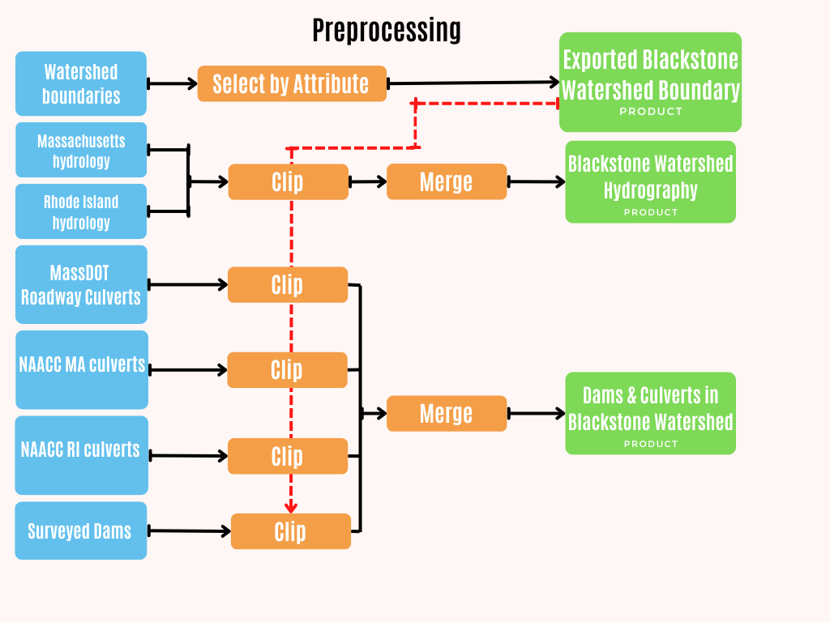
Figure 1: Pre-processing Contextual Data. Geoprocessing Tools are represented in orange.
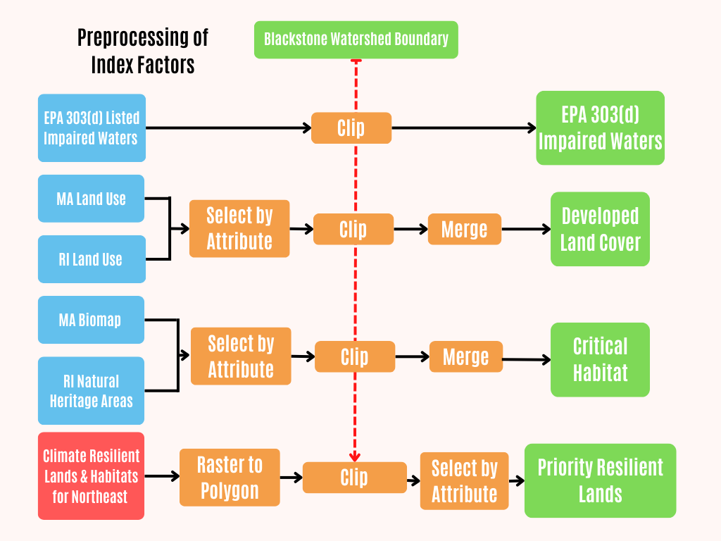
Figure 2: Pre-processing of Data for Index Factors. Geoprocessing Tools are represented in orange.

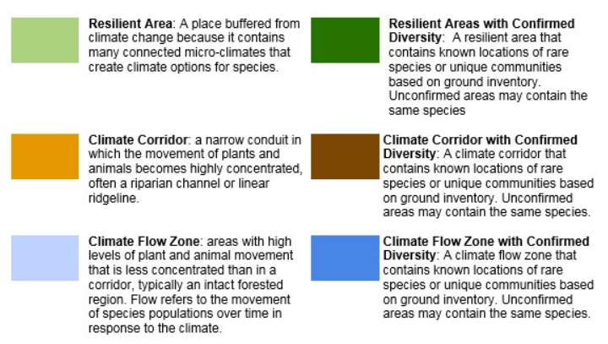
Figure 3: Resilient and Connected Networks Core Concepts defined by the Nature Conservancy

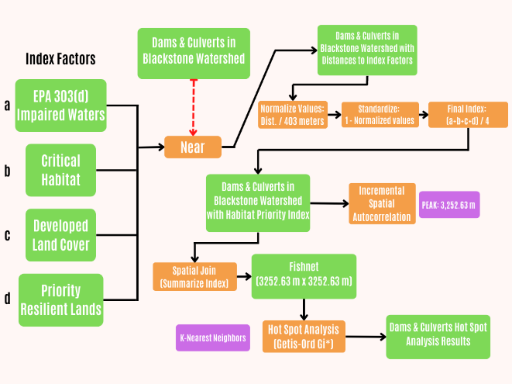
Figure 4: Final Index Analysis. Geoprocessing Tools are represented in orange.
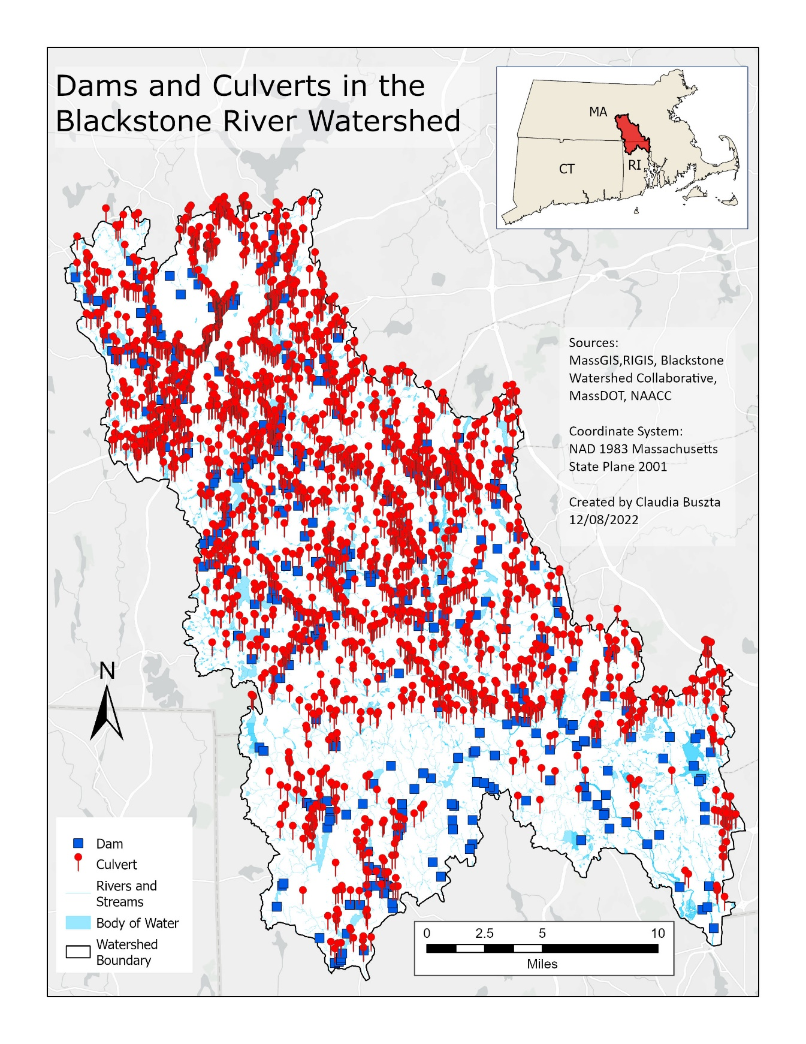
Map 1: Reference map of culvert and dam locations in the Blackstone River Watershed.
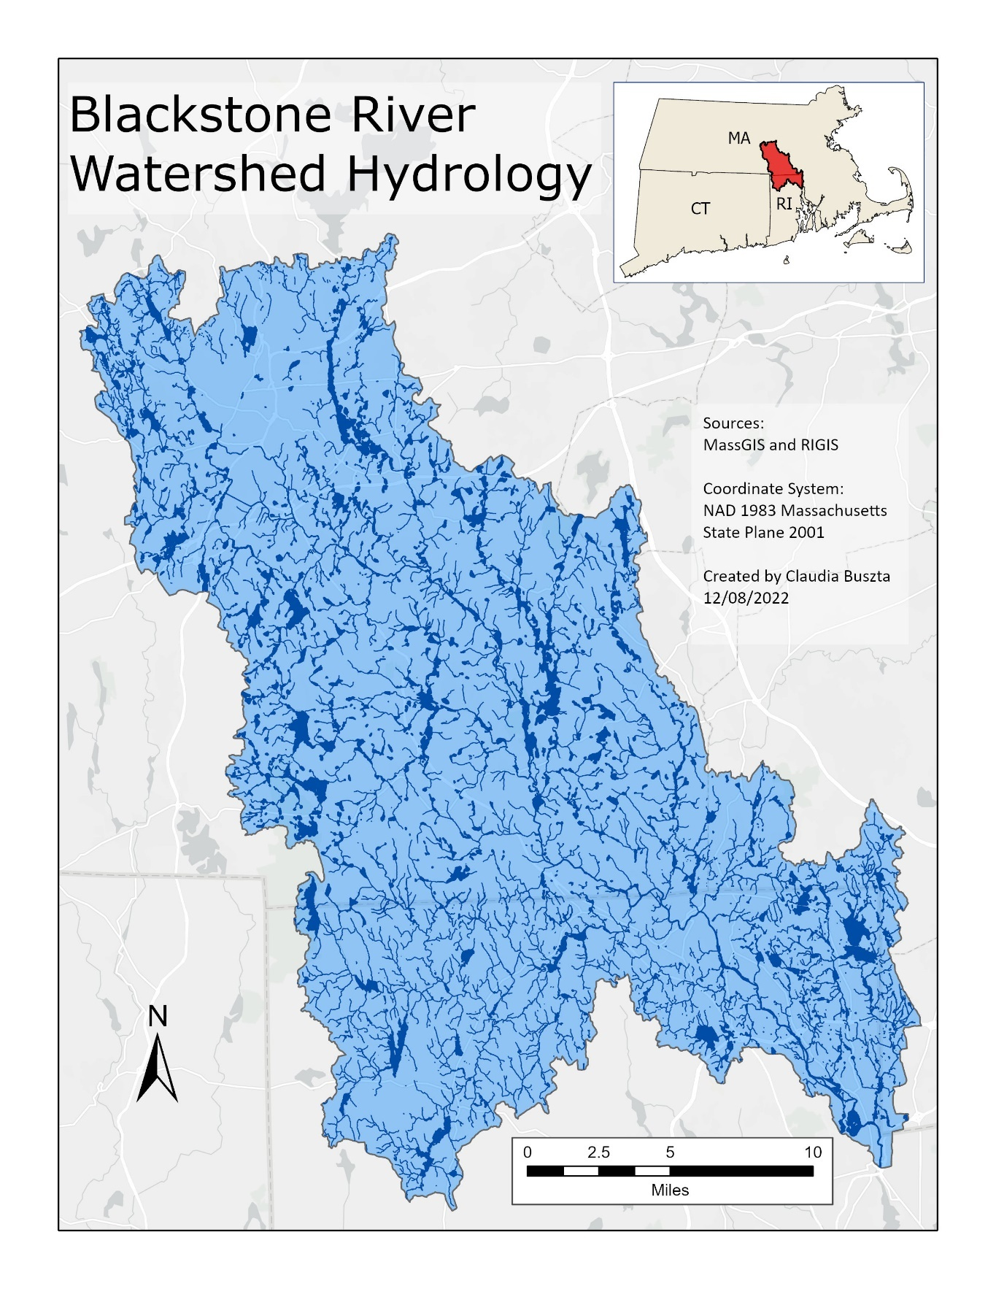
Map 2: Hydrography of the Blackstone River Watershed.
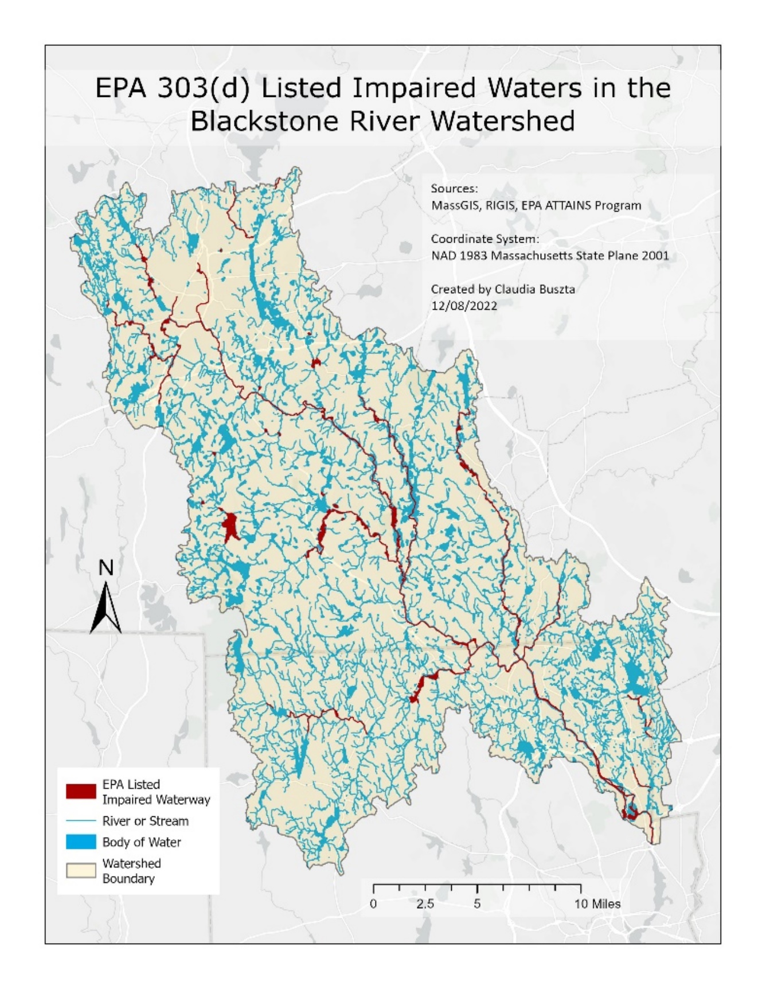
Map 3: EPA 303(d) Listed Impaired Waters in the Blackstone River Watershed.
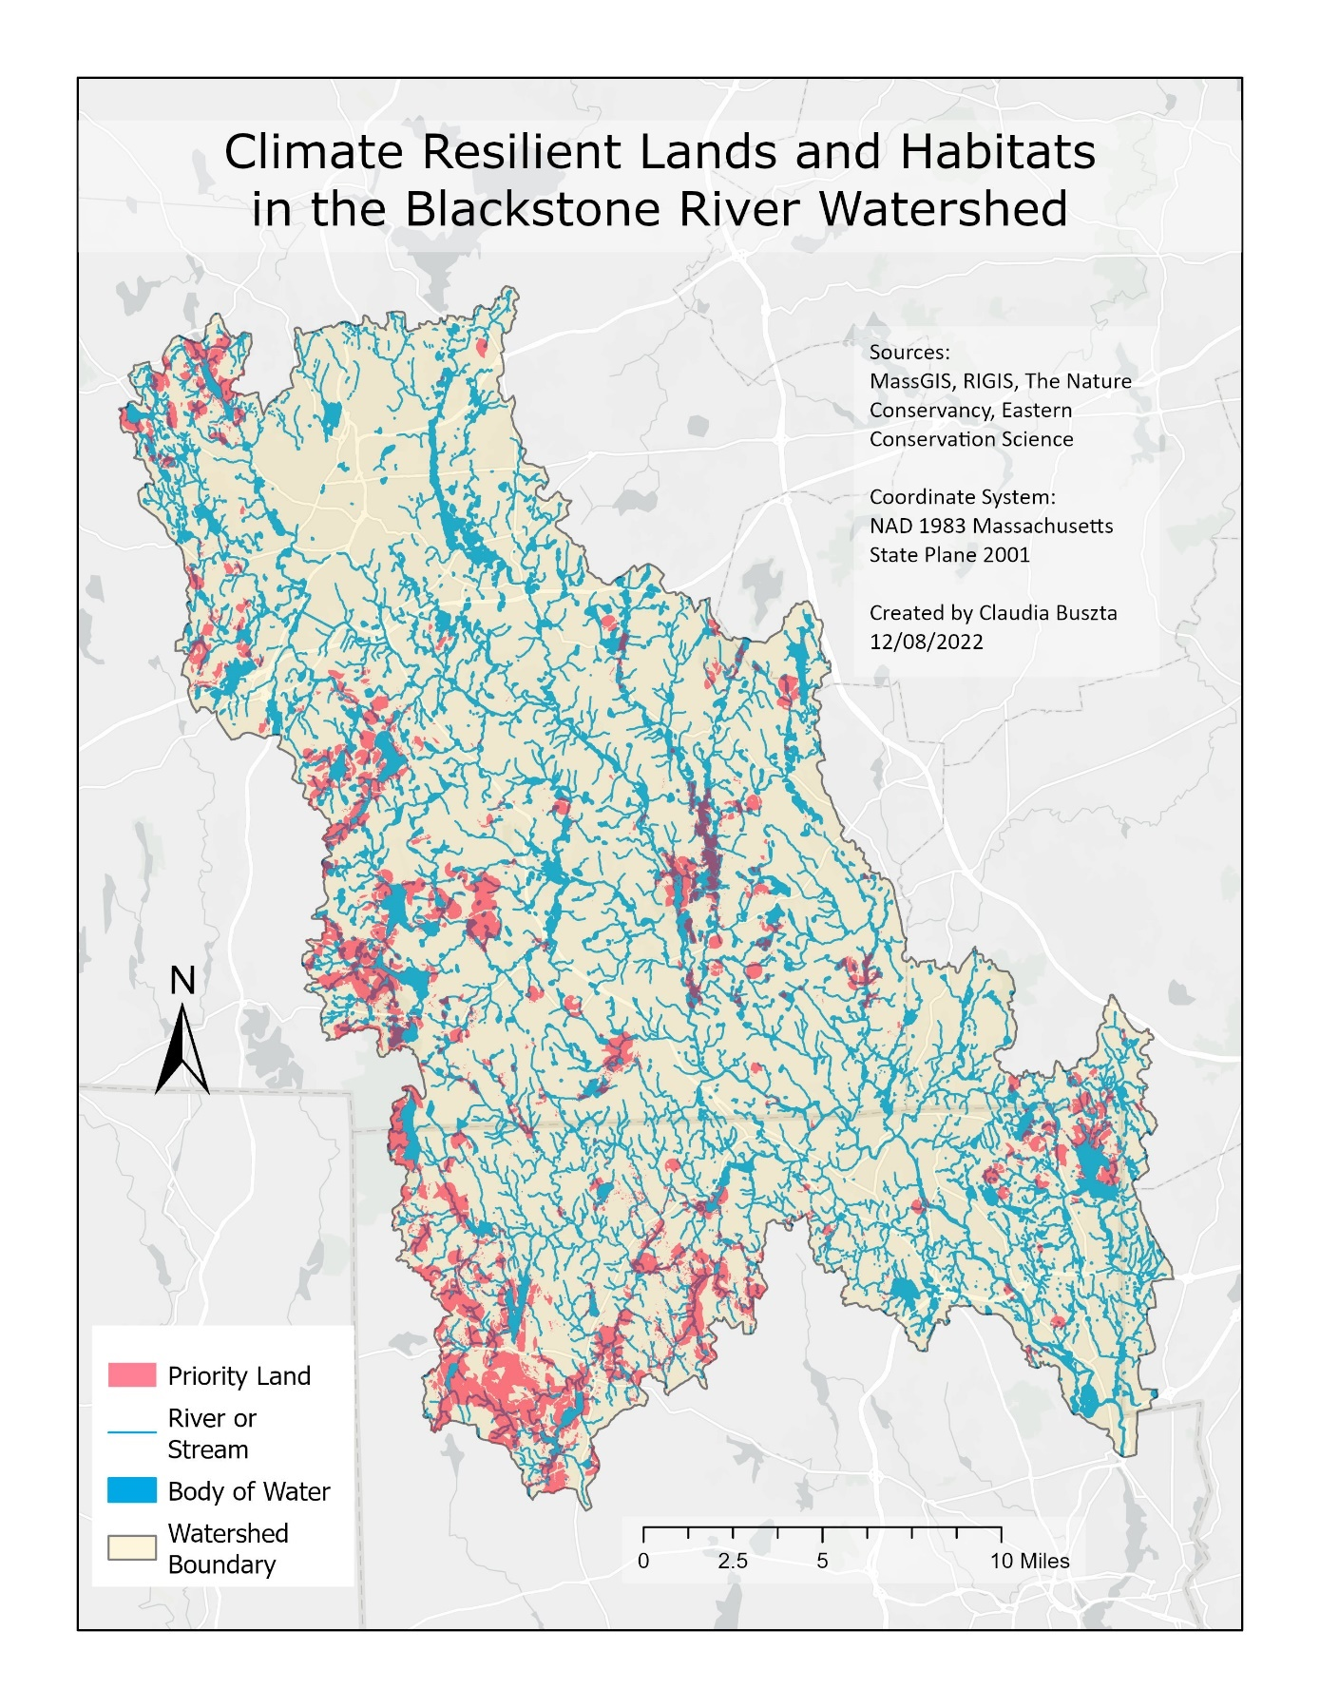
Map 4: Habitats of Critical Conservation Concern in the Blackstone River Watershed.
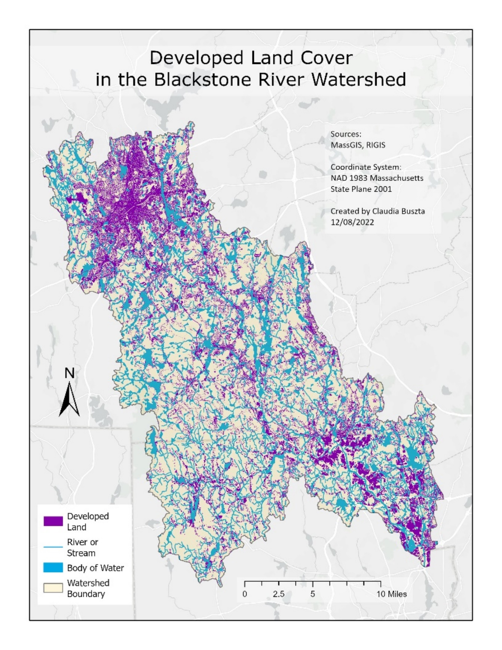
Map 5: Developed Land Cover in the Blackstone River Watershed.
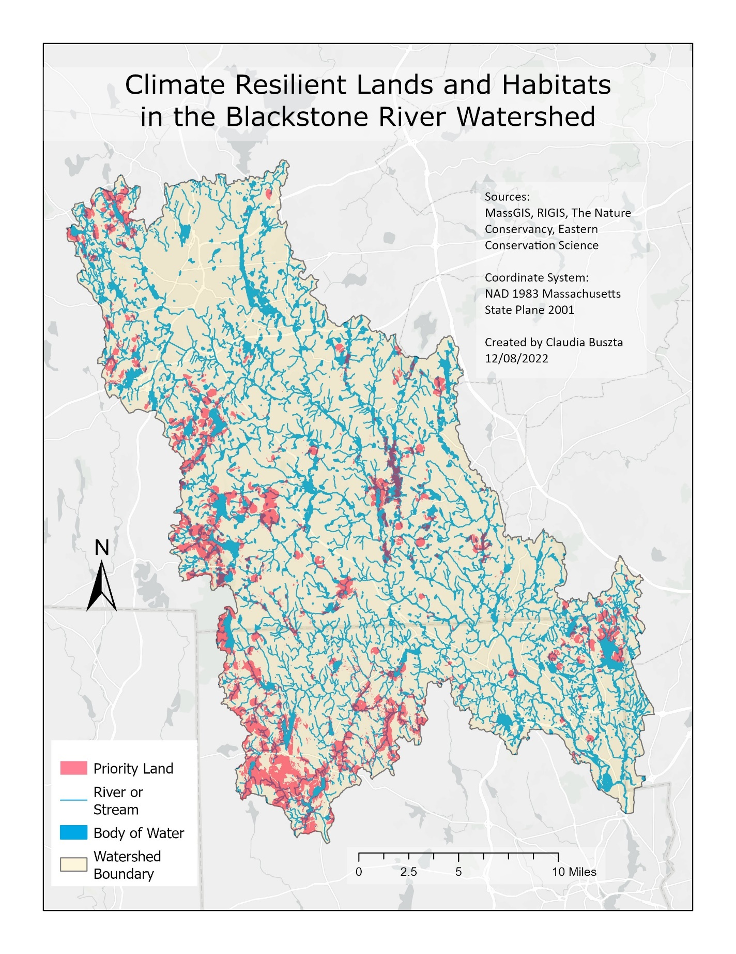
Map 6: Priority Climate Change Resilient Lands in the Blackstone River Watershed.

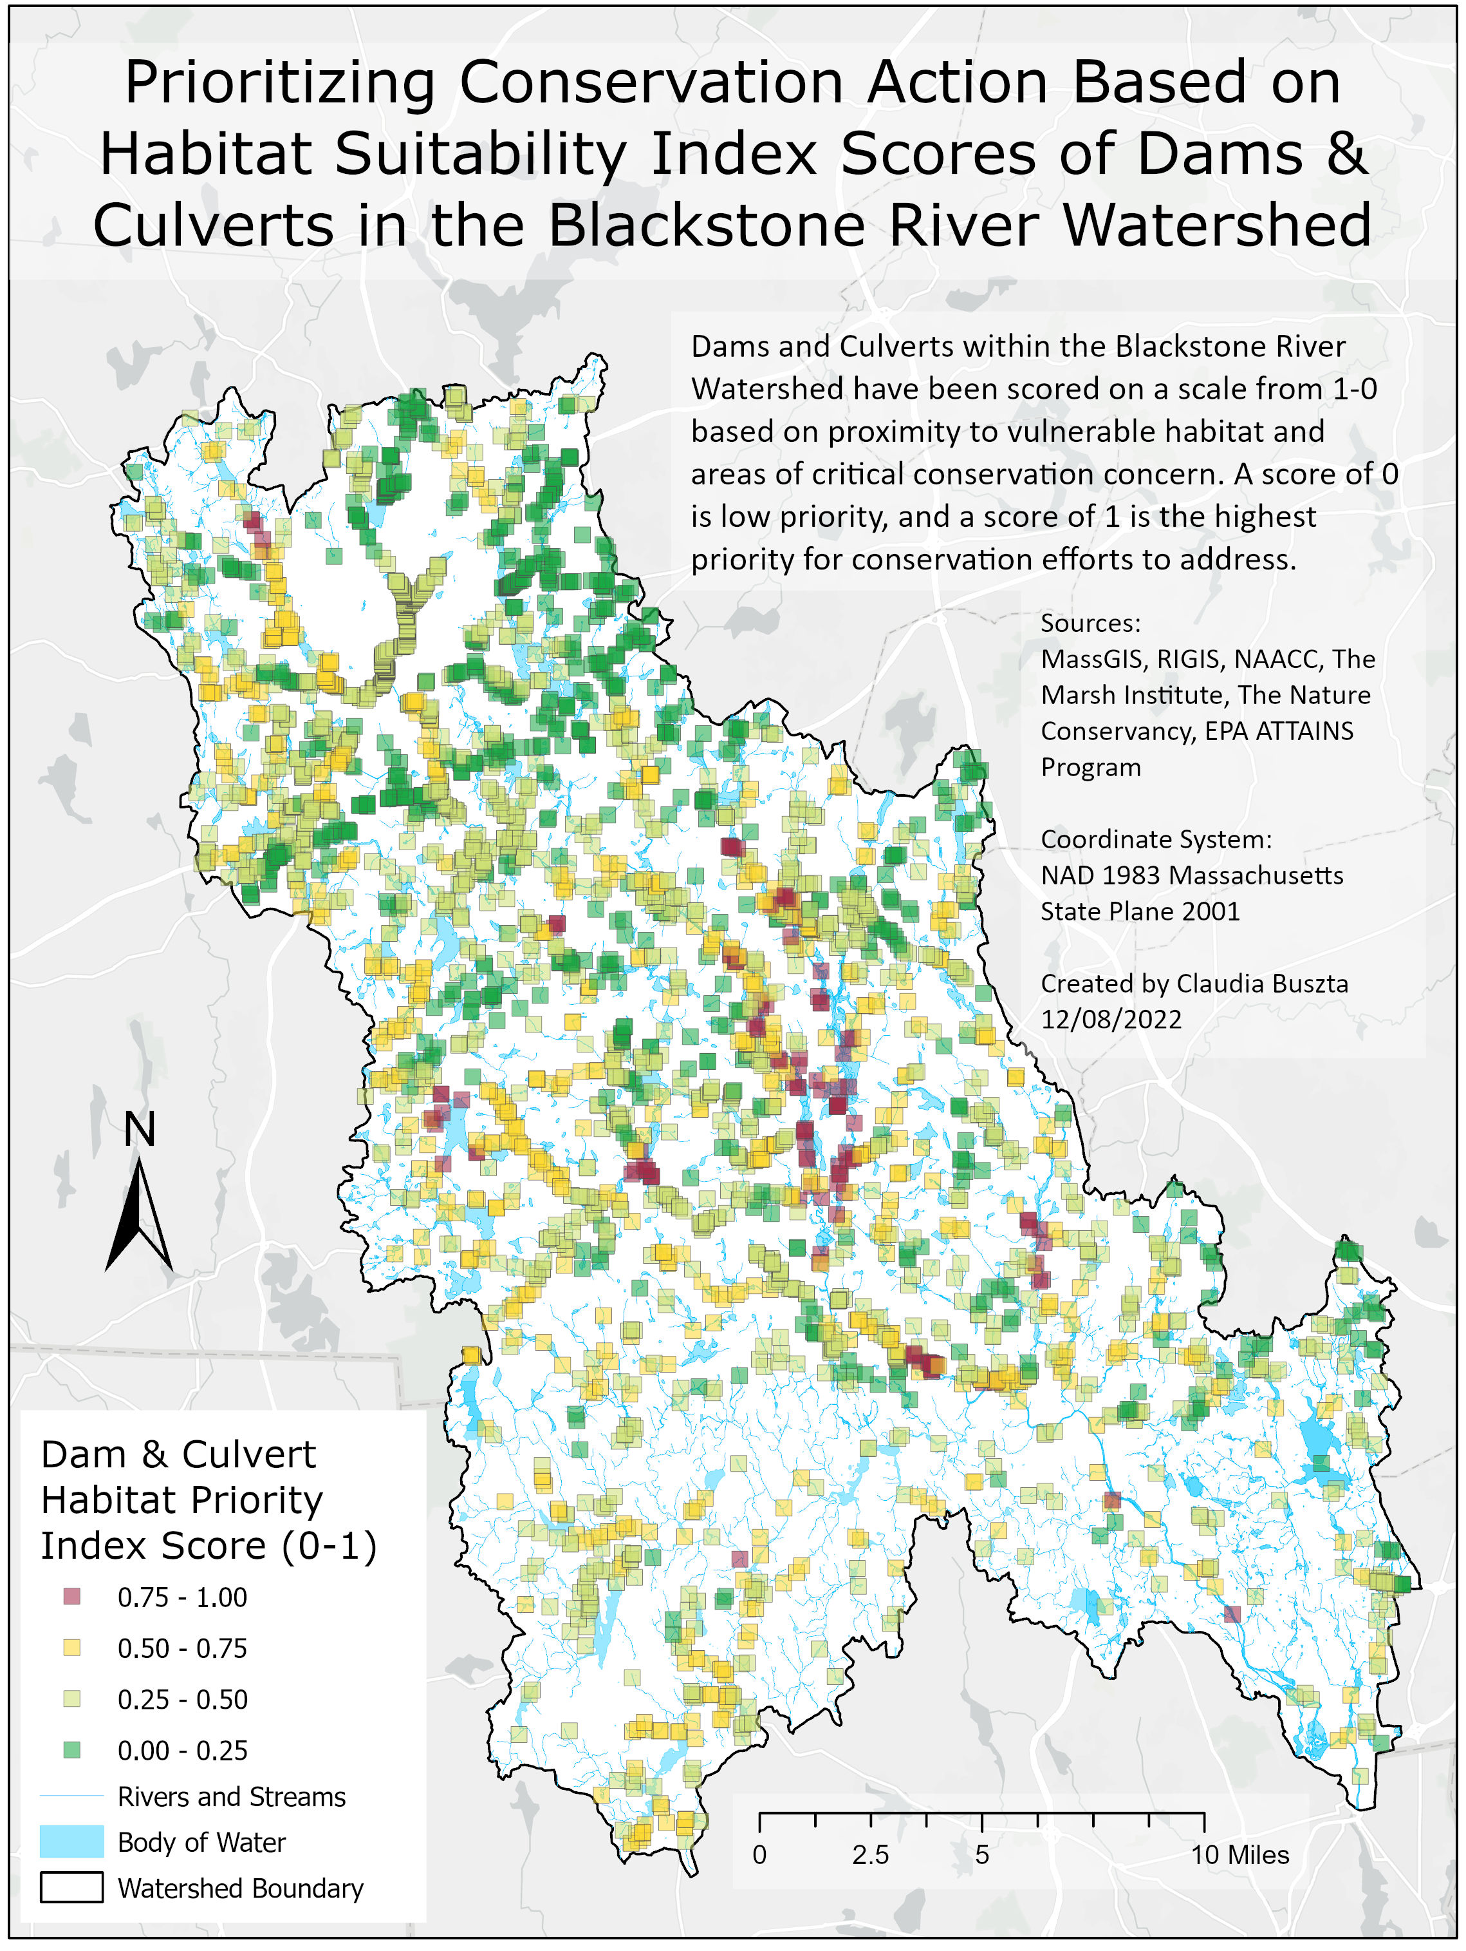
Map 7: Results of Habitat Suitability Index Analysis
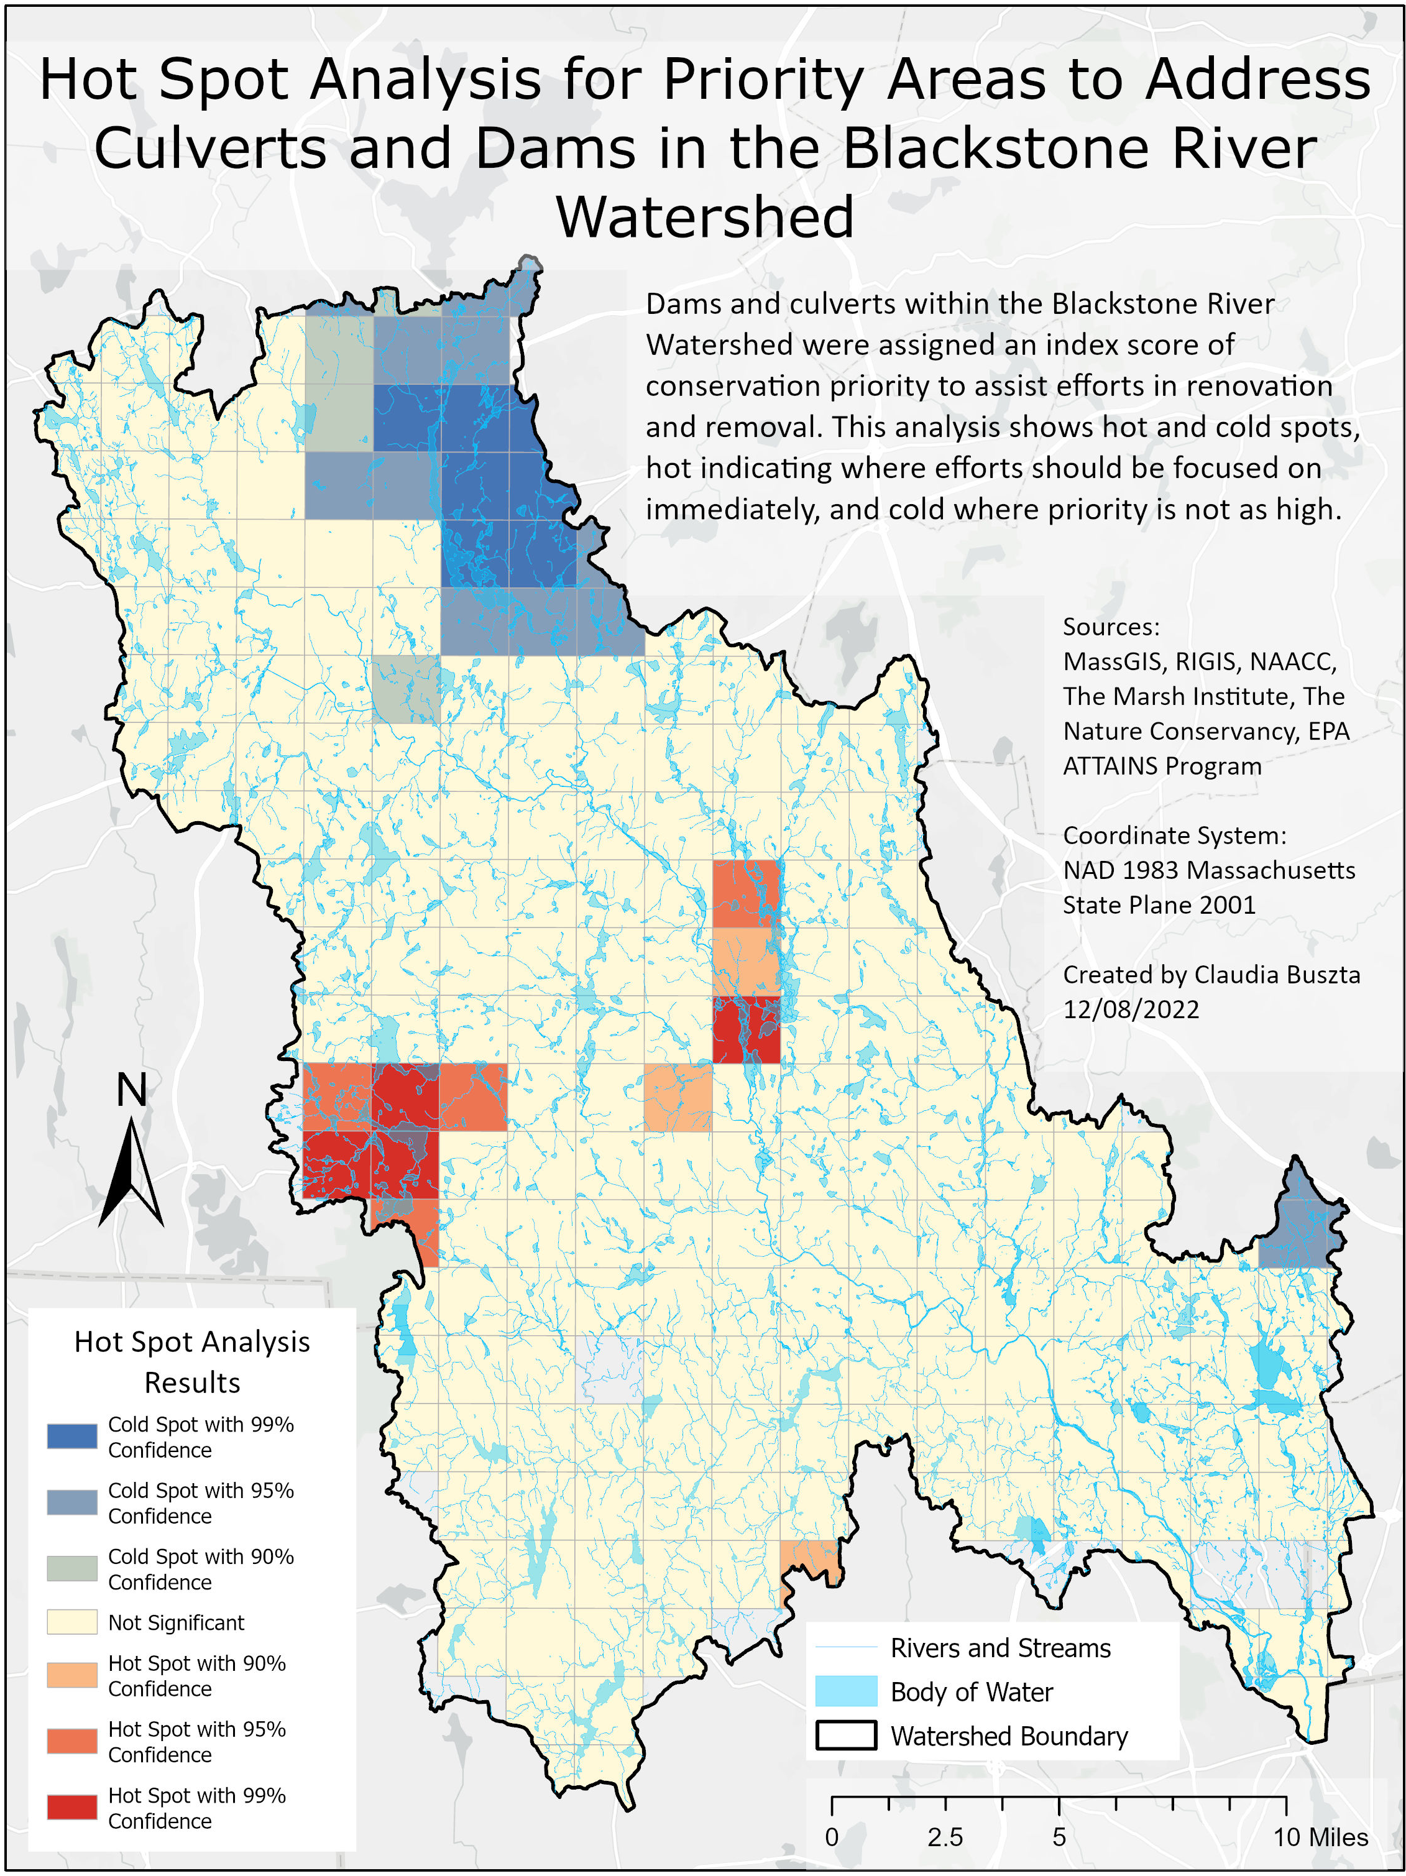
Map 8: Results of Hot Spot Analysis (Culverts & Dams)
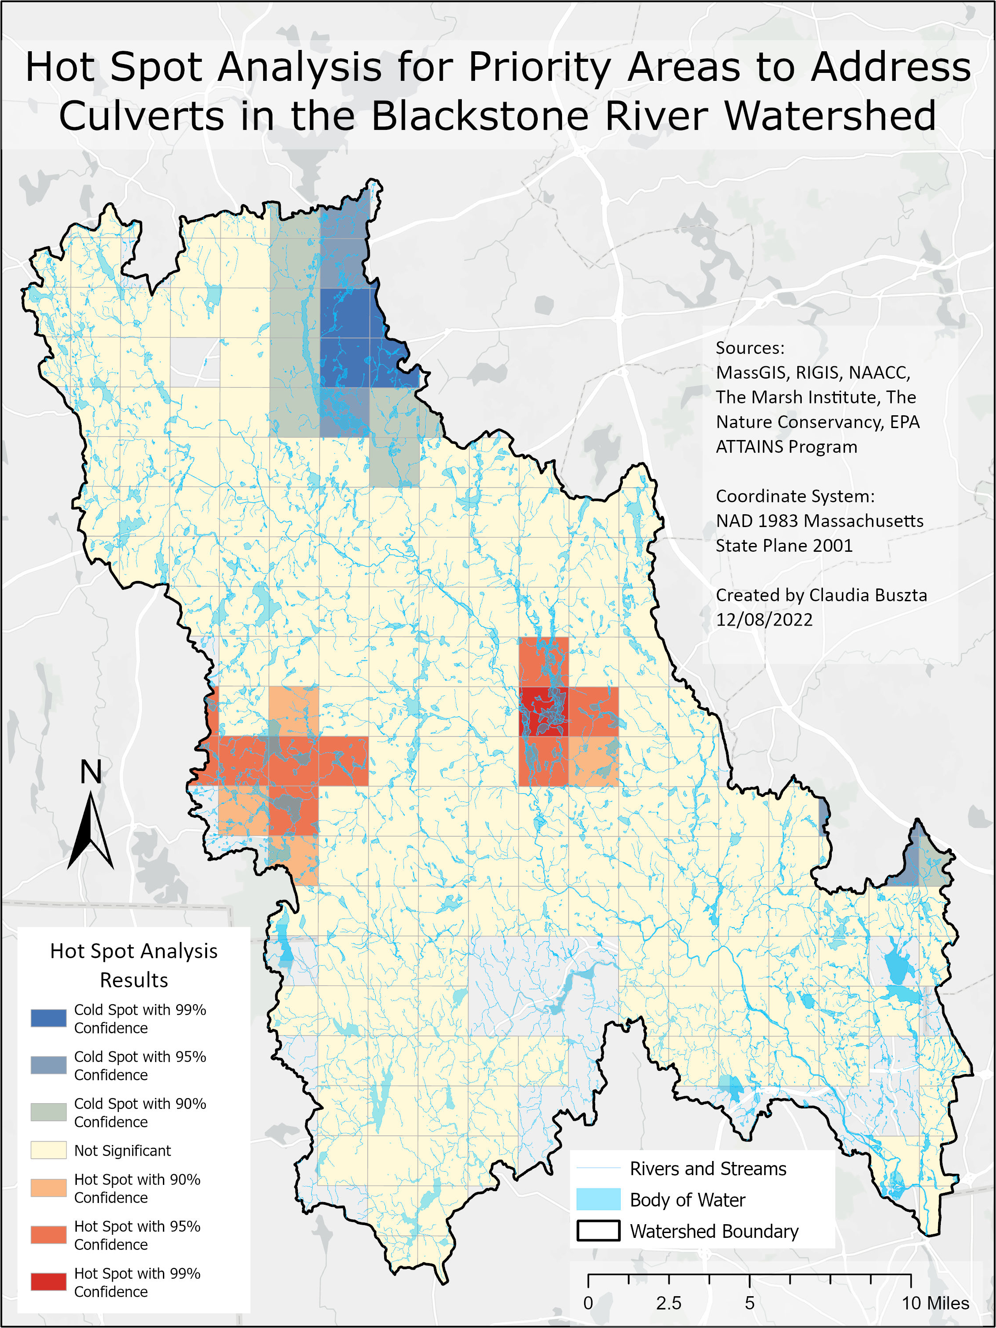
Map 9: Results of Hot Spot Analysis (Culverts Only)
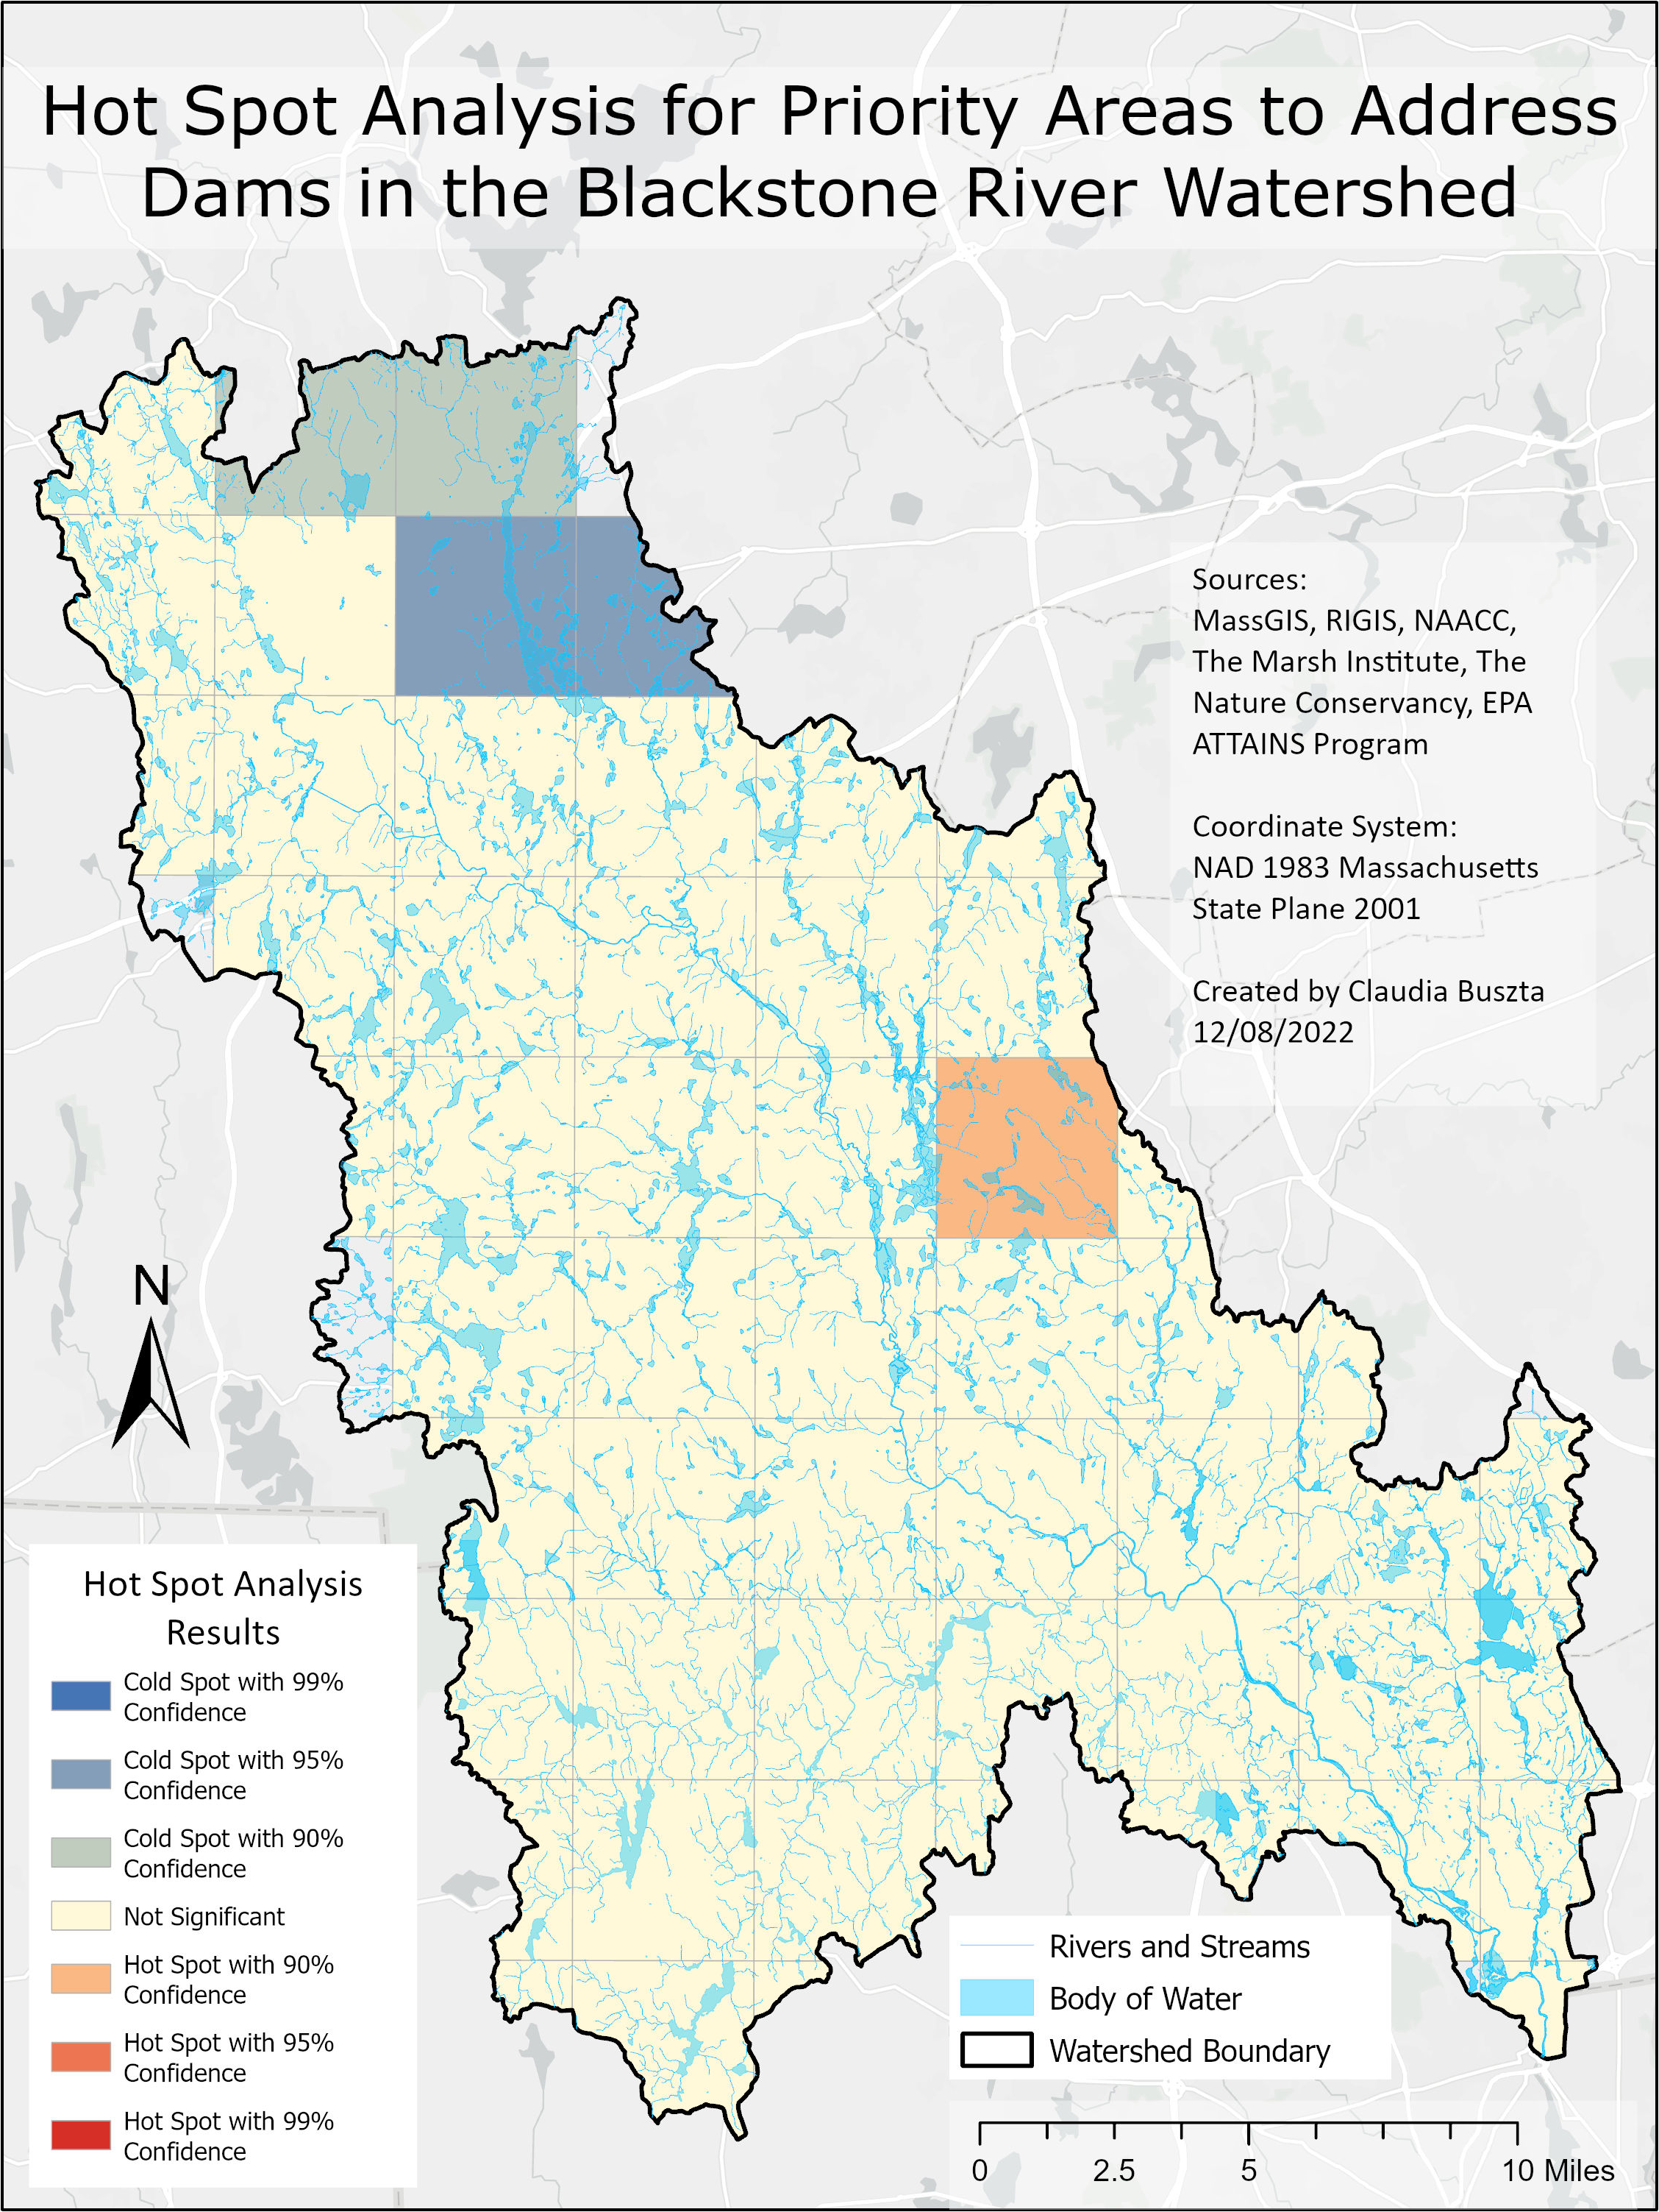
Map 10: Results of Hot Spot Analysis (Dams Only)
References
Anderson, M.G., A. Barnett, M. Clark, C. Ferree, A. Olivero Sheldon, J. Prince. 2016. Resilient
Sites for Terrestrial Conservation in Eastern North America. The Nature Conservancy, Eastern Conservation Science.
Anderson, J. R. (1976). A land use and land cover classification system for use with remote
sensor data (Vol. 964). US Government Printing Office.
Biomap, (2022). Mass Wildlife and The Nature Conservancy. Retrieved from:
https://biomap-mass-eoeea.hub.arcgis.com/
Bureau of Geographic Information (MassGIS), Commonwealth of Massachusetts, Executive
Office of Technology and Security Services
McKay, S. K., Reif, M. K., Conyngham, J., & Kohtio, D. M. (2017). Barrier prioritization in the
tributaries of the Hudson-Raritan Estuary.
Newton Hill at Elm Park, Park Spirit of Worcester, Inc. Retrieved from:
https://www.parkspirit.org/newton-hill-at-elm-park
RIGIS, 2017. Rhode Island Geographic Information System (RIGIS) Data Distribution System.
Environmental Data Center, University of Rhode Island, Kingston, Rhode Island (last date accessed: 10 April 2017
Stefanie Covino (personal communication), 2021.

